**Construction Management**

**Bachelor of Science**

**Educational Effectiveness**

**Assessment Plan**

**Adopted by:**

**The Division of Construction, Design and Safety (CDS)**

**Construction Management Program**

**April 1, 2016**

Reviewed with curriculum by the college committee as an information item: 12/8/23

Reviewed with curriculum by the dean as an information item: 12/8/23

Reviewed with curriculum by the Academic Assessment Committee as an information item: 5/3/24

Reviewed by the Faculty Senate as an information item: 5/3/24

Reviewed with curriculum changes by the Academic Assessment Committee: 10/18/19

Reviewed by the Faculty Senate as an information item: 11/1/19

Reviewed by the Academic Assessment Committee: 3/2/18

Reviewed by the Faculty Senate as an information item: 3/2/18

Contents

Construction Management Mission Statement 3

Introduction 3

BSCM PROGRAM STUDENT LEARNING OUTCOMES 4

STUDENT LEARNING OUTCOME 1 5

STUDENT LEARNING OUTCOME 2 7

STUDENT LEARNING OUTCOME 3 9

STUDENT LEARNING OUTCOME 4 10

STUDENT LEARNING OUTCOME 5 14

STUDENT LEARNING OUTCOME 6 15

STUDENT LEARNING OUTCOME 7 16

STUDENT LEARNING OUTCOME 8 18

STUDENT LEARNING OUTCOME 9 20

STUDENT LEARNING OUTCOME 10 21

STUDENT LEARNING OUTCOME 11 24

STUDENT LEARNING OUTCOME 12 26

STUDENT LEARNING OUTCOME 13 27

STUDENT LEARNING OUTCOME 14 28

STUDENT LEARNING OUTCOME 15 30

STUDENT LEARNING OUTCOME 16 31

STUDENT LEARNING OUTCOME 17 33

STUDENT LEARNING OUTCOME 18 35

STUDENT LEARNING OUTCOME 19 36

STUDENT LEARNING OUTCOME 20 37

# Construction Management Mission Statement

The mission of the Construction Management program is to prepare future industry employees with the education, skills, and training for entry-level professional positions in construction management.

**Goals**

* Provide an educational program of distinction that prepares individuals for professional careers in the construction industry.
* Provide a challenging learning environment that seeks to maximize the strengths and capabilities of each individual student.
* Strive for consistent improvement and modernization of the academic and technical quality of the degree program.
* Build a strong and mutually beneficial relationship between the program, the alumni, and the local, regional and national construction industry.

# Introduction

This Bachelor of Science in Construction Management (BSCM) Educational Effectiveness Assessment Plan identifies the twenty student learning outcomes (SLO) required to be assessed by the American Council for Construction Education (ACCE) and provides a plan for the assessment of each SLO.

All core construction courses in the BSCM program are used to provide assessment data. All data shall be collected, reviewed, and used to identify recommendations for constant improvement in the BSCM program in accordance with the BSCM Assessment Implementation Plan.

# BSCM PROGRAM STUDENT LEARNING OUTCOMES

1. Create written communications appropriate to the construction discipline.
2. Create oral presentations appropriate to the construction discipline.
3. Create a construction project safety plan.
4. Create construction project cost estimates.
5. Create construction project schedules.
6. Analyze professional decisions based on ethical principles.
7. Analyze construction documents for planning and management of construction processes.
8. Analyze methods, materials, and equipment used to construct projects.
9. Apply construction management skills as a member of a multi-disciplinary team.
10. Apply electronic-based technology to manage the construction process.
11. Apply basic surveying techniques for construction layout and control.
12. Understand different methods of project delivery and the roles and responsibilities of all constituencies involved in the design and construction process.
13. Understand construction risk management.
14. Understand construction accounting and cost control.
15. Understand construction quality assurance and control.
16. Understand construction project control processes.
17. Understand the legal implications of contract, common, and regulatory law to manage a construction project.
18. Understand the basic principles of sustainable construction.
19. Understand the basic principles of structural behavior.
20. Understand the basic principles of mechanical, electrical and piping systems

# STUDENT LEARNING OUTCOME 1

**1. Create written communications appropriate to the construction discipline.**

1.1 Source Course – CM A301 Construction Project Management II

**Assessment Data 1.1** - IP-3, Individual project 3 requires the students to prepare a Change Management Plan or a Quality Control Plan for an Alaskan based commercial construction company. This project is worth 100 points which is approximately 7 percent of their grade. They are provided with detailed information about the company such as Office employees, Type of work, Number of subcontractors, size of the typical projects, and types of changes or quality issues that might be encountered. The students are asked to write an executive summary along with supporting documentation in a professional organized format.

This project has a point value of 100 points which is approximately 7 percent of the student’s final grade for this class.

The scores for the above defined portion of the grading rubric are direct measure of each student’s written communication skills.

* Professional Appearance worthy of the workplace environment 10 Points
* The Plan well organized. 10 Points
* Grammar & Spelling. 10 Points
* All Objectives have been met or addressed. 70 Points

STUDENT LEARNING OUTCOME 1 (Continued)

1.2 Source Course – CM A450 – Construction Management Professional Practice

**Assessment Data 1.2** – The final project 10 for this course is a team based (4 students per team) response to a Request for Proposal from the Anchorage School District for an upgrade to Sand Lake Elementary School. The RFP requests a CM @ Risk method of delivery based on 35% design documents including pre-construction services. The written proposal from each team is limited to 25 pages and must respond to seven selection criteria. The grading rubric for this course includes a scored evaluation of the proposal’s written clarity, spelling, grammar, and formatting. It is this portion of the project score that is used to evaluate the student team’s ability for written communication.

A team participation report is required for every project in this course. Each student’s responsibility, hours worked, participation and contribution is identified in the report and signed by all four team members. Therefore team members may receive different scores for the same project.

The scores for the above defined portion of the grading rubric are a direct measure of each student’s written communication skills.

| Evaluation Criteria | Possible Points | Points Earned |
| --- | --- | --- |
| Font size per RFP | 3 |  |
| 11x17 used for schedule or drawings only | 3 |  |
| Proposal well organized | 6 |  |
| Grammar | 5 |  |
| Spelling | 5 |  |
| Clarity | 5 |  |
| Format | 5 |  |
| Total | 32 |  |

STUDENT LEARNING OUTCOME 1 (Continued)

1.3 Source Course – CM A201 – Construction Project Management I

**Assessment Data 1.3** - Project 5 for this course requires the students to prepare jobsite written reports and communication for an ongoing commercial project. The students are provided with the complete procurement documents for a commercial project. The students are also given current day information for the current status of the project, self-preformed work ongoing, workforce on site, daily weather, subcontractors on site, standard working hours, in addition to some jobsite problems that need to be addressed. With the provided information the students are required to write a detailed daily report for the Superintendent and 3 Request for Information (RFIs) to the architect.

This project has a point value of 50 points which is approximately 4 percent of the student’s final grade for this class.

The scores for the above defined portion of the grading rubric are direct measure of each student’s written communication skills.

**Grading Rubric**

* The document has a professional appearance and worthy of the

Workplace environment 10 Points

* Daily Report 10 Points
* RFI 1 10 Points
* RFI 2 10 Points
* RFI 3 10 Points

**Total Score 50 Points**

# STUDENT LEARNING OUTCOME 2

**2. Create oral presentations appropriate to the construction discipline.**

2.1 Source Course - CM A301 Construction Project Management II

**Assessment Data 2.1** – This course includes two Team Projects that have oral team presentations.

**Team Project 1:** Students are provided a project scenario in which student teams acting as a prospective Construction Management Firms provide formal presentations to a fictitious school board for the recommended project delivery system for a new High School project.

**Team Project 2:** Student teams interview a local general contractor, construction management firm, or property development company. The interview focus on what strategies or criteria does the company use to determine what types of work or project the will peruse? The teams must provide a written summary and formal oral presentations of their written summary.

For both Team Projects, the presentations are approximately 20 minutes. The total project score for each project is 200 points of which 75 points of the 200 points possible are for the oral presentation score.

The combined point value for both projects is 150 points which is approximately 10 percent of the student’s final grade for the class.

The scores for the above defined portion of the grading rubric are direct measure of each student’s written communication skills.

**Grading Rubric**

* Knowledge of the topic 15 Points
* Rehearsed presentation (Not reading off the power points) 15 Points
* Presentation movements, Body language, Relaxed, fluid 15 Points
* Quality of presentation graphics 15 Points
* Total time for presentation (20 minutes) 15 Points

**Total Score 75 Points**

STUDENT LEARNING OUTCOME 2 (Continued)

2.2 Source Course – CM A450 – Construction Management Professional Practice

**Assessment Data 2.2** – This course includes a total of five oral team presentations. This includes four practice presentations and one final presentation to the Senior Construction Manager and staff for the Anchorage School District, representatives of the construction company that built the project, members of the CM Industry Advisory Committee, other industry personnel, and CM faculty.

Each presentation is scored. Generally, the scoring is more difficult with each successive presentation. Each team is composed of 4 students and students are scored individually. All presentations are recorded and can be viewed by other faculty.

A grading rubric used to score each presentation. This rubric is shown below and is provided to students prior to student presentations and is based on lecture materials for public speaking.

The total points earned by each student is divided by total possible points. All student percentages are added and then divided by the number of students.

**CM A450 CM Professional Practice**

| **Grading Rubric for Oral Presentations** | Possible  Points | 1 | 2 | 3 | 4 |
| --- | --- | --- | --- | --- | --- |
| Knowledge of Topic | 20 |  |  |  |  |
| Verbal clarity | 10 |  |  |  |  |
| Ums, ahs, slang, "you guys" etc. | -15 |  |  |  |  |
| Reading off screen | -10 |  |  |  |  |
| Minimal use of note cards | 10 |  |  |  |  |
| Total time for presentation within 15 min. | 10 |  |  |  |  |
| Reasonably equal time for each team member | 5 |  |  |  |  |
| Quality of presentation graphics | 15 |  |  |  |  |
| Body language | 5 |  |  |  |  |
|  | 50 |  |  |  |  |

STUDENT LEARNING OUTCOME 2 (Continued)

2.3 Source Course – CM A102 – Methods of Building Construction

**Assessment Data 2.3**

Building Analysis, Team Project

The Building Analysis Team Project is a term length investigation of a local building. Students must choose a local building that interests them, is sizeable, and has been built within the last ten years. Students are required to go to the municipal building department and find the construction documents for the project. They must document all building systems and provide graphic evidence from the construction documents. At the end of the term students are required to present their findings to the class.

The project is worth 300 points based on the following rubric.

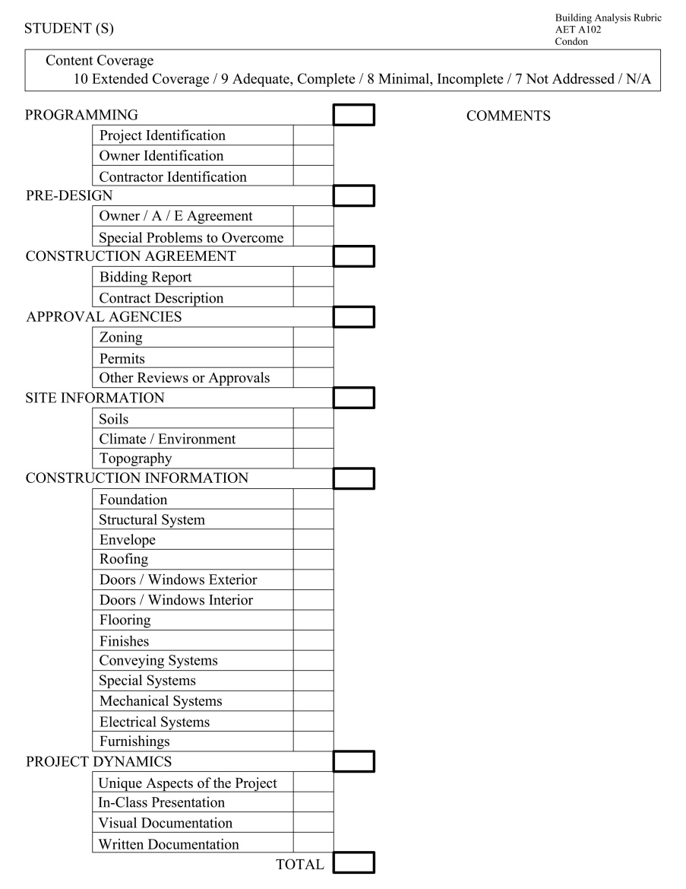

# STUDENT LEARNING OUTCOME 3

**3. Create a construction project safety plan.**

3.1 Source Course – CM A205 Construction Safety

**Assessment Data 3.1** – **Students are presented with safety plan requirements via lectures, printed materials, videos, and Illness & Injury Prevention Program (IIPP) requirements from the OSHA, Army Corps of Engineers & American National Standards Institute (ANSI). Students are also provided with a copy of an IIPP that was developed for CM A205.**

**Completion of all 30 contact hours of the OSHA 30-Hour Construction Industry Outreach Training program is considered to have met the student learning outcome.**

**In addition to this requirement, the overall score on the Take-Home Mid-Term exam is used to assess this student learning outcome.**

STUDENT LEARNING OUTCOME 3 (continued)

3.2 Source Course – CM A450 – Construction Management Professional Practice

**Assessment Data 3.2** – Project 8 in the above course requires students to prepare a project specific safety plan. The score for each team’s safety plan is recorded as a percentage out of a possible 100 points.

A grading rubric used to score each safety plan. This rubric is included in the course syllabus and is explained to the class.

**CM A450 CM Professional Practice**

| **Grading Rubric for Safety Plan - Project 8** | Possible  Points |
| --- | --- |
| On-site Safety Manager | 1 |
| Name and contact information |  |
| Identification of hazards | 10 |
| Hazard mitigation plan |  |
| Methods for communication | 5 |
| Training | 5 |
| Emergency response plan | 6 |
| Accident reporting, investigation, recording | 6 |
| Checklists and forms for all the above | 5 |
| Other areas covered than listed above | 12 |
|  | 50 |

# STUDENT LEARNING OUTCOME 4

**4. Create construction project cost estimates.**

4.1 Source Course – CM A163 – Building Construction Cost Estimating

**Assessment Data 4.1** – - The final project for this course is a detailed contractor’s cost estimate for a two million dollar commercial project. The students are divided into 2-3 person teams and asked to create fictitious construction companies. The project includes the following tasks: Detailed quantity surveys for all materials, detailed cost estimates for all self-performed work, calculation of the general composite rate, detailed estimate for all general requirements, general conditions costs including O&P, contract bond and insurance costs, subcontractor bid and material supplier analysis and packaging, acknowledgement of addendums, and preparation of the bid documents for a set bid time and date. The students then compete against each on bid day to be the lowest responsive bidder for the project.

The point value for the final project is 400 points which is approximately 20 percent of the student’s grade in the course. Additionally “Final Bid Pricing Penalty & Bonus Points” are provided to student teams offering as many as 30 additional bonus points or 30 penalty points simulating real world financial risks contractors’ face when bidding a project.

The scores for the above defined portion of the grading rubric are direct measure of each student’s ability to create a construction project cost estimate for a competitively bid commercial project.

**Grading Rubric**

* Accuracy and completeness of your estimate. 150 Points
  + Accurate quantities for self-performed work 25 Points
  + Proper means pricing for Self performed work 25 Points
  + Accurate and reasonable pricing for Division 1 50 Points
  + Bethel PATC Estimate spreadsheet 50 Points
* Proper evaluation of sub bids and quotations. 100 Points
  + Were the right combination of sub bids utilized 25 Points
  + Was Air Fare, shipping, and Roof & Board included 25 Points
  + Was there any overlapping scopes of work 25 Points
  + Was anything left out 25 Points
* Proper evaluation and acknowledgement of Addendums 50 Points
  + Were the right bid adjustments made
  + Did the bidder read the addendums carefully and follow instructions
  + Were the addendums acknowledged on the bid form
* Professional and timely submission of proposal and bid documents. 100 Points
  + Were the bid documents complete and professional? 20 Points
  + Were the bid documents filled out correctly? 20 Points
  + Were the bid documents submitted on time? (10 %) 40 Points

4.1 Source Course – CM A163 – Building Construction Cost Estimating (continued)

* Final Bid Pricing Penalty & Bonus Points
  + Basic Bid is too High (10 % above the 2nd highest bidder) -20 Points
  + Basic Bid is way to High (20 % above the 2nd highest bidder) -30 Points
  + Basic Bid is too Low (10% below the 2nd lowest bidder) -20 Points
  + Basic Bid is way too Low (20% below the 2nd lowest bidder) -30 Points
  + Basic Bid is the 1st Low Responsive Bid +30 Points
  + Basic Bid is the 2nd Low Responsive Bid +20 Points
  + Basic Bid is the 3rd Low Responsive Bid +10 Points

STUDENT LEARNING OUTCOME 4 (Continued)

4.2 Source Course – CM A263 – Civil Construction Cost Estimating

**Assessment Data 4.2** – The final cost estimate in this class, Estimate 11, uses previous estimates for quantity take offs and equipment selection as indicated below. Estimate 11 includes material, labor, and equipment direct costs, same of indirect costs, all Division One costs, overhead, bonding and insurance, contingency and profit. Estimate 11 also requires an equipment utilization schedule to level resources.

Estimate 3 – Average End Area Method – 3500 lineal feet of railroad bed – cut and fill quantities Estimate 4 – Soil profile and mass diagram to establish haul plan

Estimate 5 – Grid Cell Method – Cut and fill quantities – 157,500 square foot parking lot

Estimate 6 – Quantity take off for utility installations

Storm sewer

Sanitary sewer

Water line

Telecommunications duct bank

Electrical duct bank

Estimate 9 – RR bed equipment selection and duration calculations

Estimate 10 – Parking lot and utility equipment selection and duration calculations

A grading rubric is used to score each final estimate. This rubric is included in the estimate assignment.

| CM A263 Civil Cost Estimating  Final Estimate 11 - Grading Rubric |  |
| --- | --- |
| Equipment Use Schedule |  |
| For each haul - work package | 8 |
| Total equipment on site per day | 7 |
| Clearing and Grubbing | 5 |
| Dewatering | 5 |
| Division One Costs | 13 |
| Costs per haul - RR | 13 |
| Costs per haul - Parking | 10 |
| Cost to install sewer | 13 |
| Cost to install other assigned utility | 13 |
| Organization of estimate | 13 |
|  | 100 |

STUDENT LEARNING OUTCOME 4 (Continued)

4.3 Source Course – CM A450 – Construction Management Professional Practice

**Assessment Data 4.3** – This course is based on a Request for Proposal from the Anchorage School District for an upgrade to Sand Lake Elementary School. The class is divided into teams of 4 students each. The RFP requests a CM @ Risk method of delivery based on 35% design documents including pre-construction services. A proposal is developed by each team in response to the selection criteria in the RFP.

At 60% design the selected team is to propose a Guaranteed Maximum Price (GMP) to construct the project. In preparation for this requirement, student teams prepare a work breakdown structure, CPM schedule, and cost estimate to be used in development of the GMP.

Project 5 is the Cost Estimate for the project. The estimate includes self-performed work and nearly 100 subcontractor quotes for various work packages to complete the project. The estimate includes subcontractor bid analysis and scope alignment. The estimate must also include Division One and other soft costs, bonding and insurance, overhead, contingency, and profit.

A grading rubric is used to score each final estimate. This rubric is included in the estimate assignment.

**CM A450 - CM Professional Practice**

| **Project 5 Cost Estimate - Grading Rubric** | Possible Points |
| --- | --- |
| GMP | 10 |
| Division One Costs | 28 |
| Self-Performed Work - QTO & Cost | 28 |
| Schedule of Values | 28 |
| Sub-bid Analysis | 28 |
| Organization of estimate & SOV | 28 |
|  | 150 |

# STUDENT LEARNING OUTCOME 5

**5. Create construction project schedules.**

5.1 Source Course – CM A202 – Project Planning and Scheduling

**Assessment Data 5.1** - Project 5 for this course is the preparation of a detailed construction schedule for a large commercial project (approximately 100 activities). The students are divided into 2 person teams and asked to create this detailed CMP schedule. The project is broken up into two separate parts or submissions each worth 75 points. The students are given plans and project narrative with construing dates.

**Submission 1:** The student teams are asked to identify all activities, create a work breakdown structure, estimate activity durations, hand draft a CMP schedule, perform a forward pass calculating project duration, and calculate both early start and early finish dates.

**Submission 2:** Based on the student teams completed work in Submission 1, the student teams may proceed to develop their project schedule using Microsoft Project software. The final submission 2 includes a printed CPM network diagram. The network diagram must identify the following; Milestone dates, ES-EF-LS-LF, activity float, total float, and a critical path.

The point value for project 5 is 150 points which is approximately 15 percent of the student’s grade in the course. An additional 25 bonus points are available to student teams who elect to complete submission 2 in P6 (Primavera 6) instead of MS Project. P6 is not featured in this course so outside training must be obtaining in order to use P6.

The scores for the above defined portion of the grading rubric are direct measure of each student’s ability to create a construction project CPM schedule for a commercial project.

**Grading Rubric**

* Submission 1 (Hand Drawn CPM Schedule) 75 Points
  + Proper Activity logic 25 Points
  + Proper Activity Identification 25 Points
  + Forward Pass w/ ES,LS, Project Duration 25 Points
* Submission 2 (M.S. Project Network Diagram) 75 Points
  + Milestone Dates 25 Points
  + Schedule logic (No unconnected activities) 25 Points
  + Critical Path & does the schedule make since 25 Points
* Bonus Points - Submission 2 completed in P-6 software 25 Points

STUDENT LEARNING OUTCOME 5 (continued)

5.2 Source Course – CM A450 – Construction Management Professional Practice

**Assessment Data 5.2** – This course is based on a Request for Proposal from the Anchorage School District for an upgrade to Sand Lake Elementary School. The class is divided into teams of 4 students each. The RFP requests a CM @ Risk method of delivery based on 35% design documents including pre-construction services. A proposal is developed by each team in response to the selection criteria in the RFP.

To respond to the RFP student teams must create a CPM Schedule which is Project 6.

A grading rubric is used to score each schedule. This rubric is included in the course syllabus and is explained to the class.

**CM A450 - CM Professional Practice**

| **Project 6 CPM Schedule - Grading Rubric** | Possible Points |
| --- | --- |
| Consistent with Construction Phasing Plan | 15 |
| Start with NTP on site | 8 |
| Show ASD milestones | 15 |
| Logical sequence of work activities | 22 |
| Activity durations reasonable | 30 |
| Show Substantial and Final Completion | 15 |
| Show critical path | 30 |
| Define process for tracking and updating schedule | 15 |
|  | 150 |

# STUDENT LEARNING OUTCOME 6

**6. Analyze professional decisions based on ethical principles.**

6.1 Source Course – CM A205 – Construction Safety

**Assessment Data 6.1** - **Students are presented with profession ethics considerations along with common industry practices and discussions related to good and bad ethical decision-making.**

There are five (5) questions embedded in the Take-Home Mid-Term exam pertaining directly to ethical issues. These five (5) questions are scored collectively to determine if students have met this student learning outcome.

STUDENT LEARNING OUTCOME 6 (continued)

6.2 Source Course – CM A401 – Construction Law

**Assessment Data 6.2** -

Student teams are given a narrative containing factual scenarios containing five independent ethical issues. Each team is to analyze the scenarios and identify the ethical issue and determine an ethical course of action in response to each issue.

The exercise is assessed as follows:

Points

Correct identification of Issue 1 10

Issue 2 10

Issue 3 10

Issue 4 10

Issue 5 10

Correct response to Issue 1 10

Issue 2 10

Issue 3 10

Issue 4 10

Issue 5 10

Possible Total 100

# STUDENT LEARNING OUTCOME 7

**7. Analyze construction documents for planning and management of construction processes.**

7.1 Source Course – CM A301 – Construction Project Management II

**Assessment Data 7.1** - Individual Project 1 is the analysis of procurement documents for a large commercial project. The students assist a fictional construction firm for the preparation of bid documents for a large complex commercial project. They are asked to research the procurement documents in order to answer a variety of key questions relevant in the bidding process for this project.

This project has a point value of 100 points which is approximately 7 percent of the student’s final grade for this class.

The scores for the above defined portion of the grading rubric are direct measure of each student’s ability to analyze construction documents for planning and management of the construction process.

**Grading Rubric**

* The document has a professional appearance and worthy of the

Workplace environment 20 Points

* The student correctly answers all 20 questions 80 Points

**Total Score 100 Points**

STUDENT LEARNING OUTCOME 7 (continued)

7.2 Source Course – CM A450 – Construction Management Professional Practice

**Assessment Data 7.2** - This course is based on a Request for Proposal from the Anchorage School District for an upgrade to Sand Lake Elementary School. The class is divided into teams of 4 students each. The RFP requests a CM @ Risk method of delivery based on 35% design documents including pre-construction services. A proposal is developed by each team in response to the selection criteria in the RFP.

To respond to the RFP student teams must create a Construction Phasing Plan which is Project 2. Students must read all drawings and specifications to establish construction sequence requirements. The project is an occupied site during the school year and has specific milestones and temporary facility requirements.

A grading rubric is used to score each Construction Phasing Plan. This rubric is included in the course syllabus and is explained to the class.

**CM A450 - CM Professional Practice**

| **Project 2 Construction Phasing Plan - Grading Rubric** | Possible  Points |
| --- | --- |
| Phase 1 - Existing Site Final Phase - Final Site Plan | 7 |
| Clear sequence of renovation, demo, new constr. | 30 |
| Replace space that is out of service | 15 |
| Dates on plans - Clearly indicate SUMMER ops | 8 |
| Fencing and Gates | 9 |
| Parking | 9 |
| Vehicle circulation | 9 |
| Pedestrian circulation | 9 |
| Student drop off | 9 |
| Bus loading and unloading | 9 |
| Traffic control | 9 |
| Access to existing and new school | 9 |
| Maintain required exits | 9 |
| Fire lane | 9 |
|  | 150 |

# STUDENT LEARNING OUTCOME 8

**8. Analyze methods, materials, and equipment used to construct projects.**

8.1 Source Course – CM A263 – Construction Civil Cost Estimating

**Assessment Data 8.1** - The focus of these two estimates is to select equipment from an established fleet mix based on tasks to be completed and quantities of materials to be excavated, cut, filled, placed, and compacted. Quantities of materials and equipment capacity is used to calculate durations for each operation.

This requires students to analyze methods of operation for each task, analyze types of materials to be excavated, cut, filled, placed, and compacted. These estimates require students to analyze what equipment is most efficient to perform each operation.

Estimate 9 – RR bed equipment selection and duration calculations

Estimate 10 – Parking lot and utility equipment selection and duration calculations

A grading rubric is not used in these two estimates. Excel calculators are used to calculate each operation and the appropriate equipment to be used based on work task duration, equipment capacity, and cost. It is therefore essential that each student enter correct quantities and use accurate data such as average haul distance, percent grade, equipment cycle times, and job efficiency factors in each equipment calculator.

The average scores for these two estimates is used to measure the students’ ability to analyze civil construction operations and select appropriate methods, materials, and equipment.

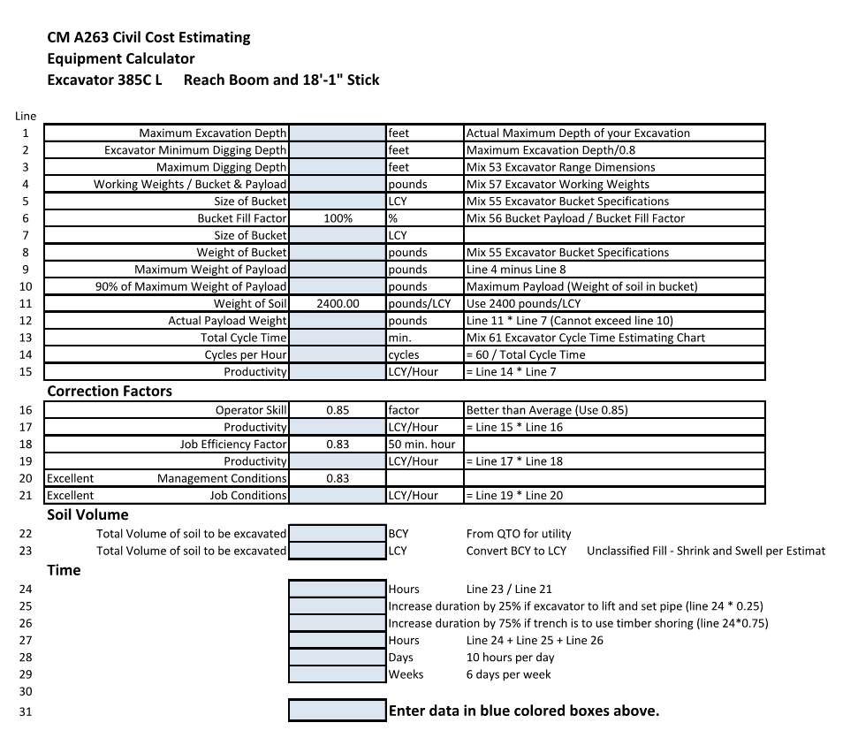

STUDENT LEARNING OUTCOME 8 (continued)

8.2 Source Course – CM A460 – Construction Equipment Management and Methods

**Assessment Data 8.2** - Test 3 is a take home test that includes the following problems: Analysis of OSHA safety requirements for a concrete project, concrete formwork lateral pressure calculations for a concrete pour, concrete pump truck location, site plan equipment selection with crane location section for a piling project, and a crane location and selection problem for a large stadium project.

This project has a point value of 160 points which is approximately 10 percent of the student’s final grade for this class.

The scores for the above defined portion of the grading rubric are direct measure of each student’s ability to analyze methods, materials, and equipment used to construct projects.

**Grading Rubric**

* Analysis of OSHA Safety requirements on site 20 Points
* Concrete formwork lateral pressure calculations 10 Points
* Concrete Pump Truck location selection 35 Points
* Site plan equipment selection and Crane location (Piling Project) 40 Points
* Crane Selection and setup location (Large Stadium Project) 55 Points

**Total Score 160 Points**

STUDENT LEARNING OUTCOME 8 (Continued)

8.3 Source Course – CM A313 – Soils in Construction

Project 4 – Soil Sieve Analysis and Soil Classification

In Project 4, students are given weights retained on a series of sieves and are asked to establish the total weight of the sample, the total weight passing each sieve, the percent finer than each sieve, uniformity coefficient, the coefficient of curvature, percent fines, percent sand, and percent gravel.

The liquid limit and plastic limit are given and students are required to classify the soil using both the unified soil classification system and the ASHTO soil classification system.

# STUDENT LEARNING OUTCOME 9

**9. Apply construction management skills as a member of a multi-disciplinary team.**

9.1 Source Course - CM A301 – Construction Project Management II

**Assessment Data 9.1** - Team Project 1 for this course provides a project scenario in which student teams acting as a prospective Construction Management Firms provide formal presentations to a fictitious school board for the recommended project delivery system for a new High School project. The students are asked to create a fictional construction management company including stationary with letterhead, a brief statement of the firm’s qualifications, and a list of team members with their various job titles for a construction management firm. The team’s final deliverables include a Statement of Interest, executive summary with recommendations, and oral presentation to the fictitious school board.

This project has a point value of 200 points which is approximately 13 percent of the student’s final grade for this class.

The scores for the above defined portion of the grading rubric are direct measure of each student’s application of construction management skills as a member of a multi-disciplinary team.

**Grading Rubric**

* Statement of Interest: 25 points
* Oral Presentations: 75 points
* Executive Summary and Recommendation (hard copy): 75 points
* Team Member Scores: 25 points

**Total Score 200 Points**

STUDENT LEARNING OUTCOME 9 (continued)

9.2 Source Course - CM A450 – Construction Management Professional Practice

**Assessment Data 9.2** - This course is based on a Request for Proposal from the Anchorage School District for an upgrade to Sand Lake Elementary School. The class is divided into teams of 4 students each. The RFP requests a CM @ Risk method of delivery based on 35% design documents including pre-construction services. A proposal is developed by each team in response to the selection criteria in the RFP.

Project 3 in this course is an exercise in developing a comprehensive list of preconstruction services appropriate to the project. The project includes a clear description of the purpose and advantage to the project of each listed service. Identification of the format of deliverable is required. For each preconstruction service the role of the constructor, the design team, and the owner must be clearly defined to establish a collaborative approach.

A grading rubric is used to score each list of proposed services and the associated required deliverables.

| **Rubric for Project 3** | Possible  Points | Awarded  Points |
| --- | --- | --- |
| Comprehensive list of services | 20 |  |
| Services that are relevant to the Sand Lake | 20 |  |
| Renewal project at 35% to 65% design. |  |  |
| Purpose of service | 10 |  |
| Well defined role of |  |  |
| Constructor | 20 |  |
| Designer |  |  |
| Owner |  |  |
| Deliverable(s) |  |  |
| Content | 10 |  |
| Format | 10 |  |
| Purpose | 10 |  |
| Value Engineering Report | 50 |  |
| **TOTAL** | 150 |  |

# STUDENT LEARNING OUTCOME 10

**10. Apply electronic-based technology to manage the construction process.**

10.1 Source Course – AET A101 – Fundamentals of CADD

**Assessment Data 10.1** -

Assignment 6: Sections:

*Fundamentals of CADD for Building Construction* introduces students to AutoCAD in the creation and use of construction drawings. Assignment 6 asks students to build on their understanding of how to make and read construction documents by using floor plans and elevations that they have developed in previous assignments to create section drawings of a building. They are required to reference door and window schedules to understand the symbols used in construction documents and how symbols are used to navigate a set of construction documents. Students must understand the configuration of building components and accurately draw and locate them in reference to a floor plan. Students must identify section symbols and understand what building elements are communicated in a section drawing.

The assignment is worth 100 points based on the following rubric.

| **CRITERIA** | **POINTS** |
| --- | --- |
| Punctuality | 20 |
| Accuracy | 20 |
| Completion | 20 |
| Comprehension | 20 |
| Presentation | 20 |

STUDENT LEARNING OUTCOME 10 (continued)

10.2 Source Course – CM A213 – Civil Technology

**Assessment Data 10.2** - This course outlines the elements of civil design. The students become familiar with all the major design tasks in a civil project. The students employ Autodesk Civil 3D to go from field information to finished design.

Lab 2: Students identify data collected in the field, convert it to a known surveying format file, setup a coordinate system and import the information using Civil 3D. The process includes the creation of drawings with the survey data points of known existing features. Using this information students create and identify an existing surface to be used as a base for the design of a proposed site. Future projects will use this as a base for other design elements.

Lab 2 is worth 10 points based on the following rubric.

| **CRITERIA** | **POINTS** |
| --- | --- |
| Process | 2 |
| Accuracy | 2 |
| Completion | 2 |
| Comprehension | 2 |
| Presentation | 2 |

STUDENT LEARNING OUTCOME 10 (Continued)

10.3 Source Course – CM A450 – Construction Management Professional Practice

**Assessment Data 10.3** – The following software programs are used by students to produce required projects and presentations;

Ten projects are required for this course. Students use most of the cited software, if not all software listed to complete the required projects.

Examples of all project work products are available for review in the CM A450 course files.

To assess the success of students in this course, we average all final passing grades. A score of 80% or better is an indication that students successfully utilized provided software to complete required projects.

**Product** **Software**

Construction Phasing Plans Auto CADD

Cost Estimate Blue Beam

Planswift

MS Excel

CPM Schedule MS Project

Primavera 6

Presentation Slides MS PowerPoint

Narrative / essays MS Word

Every project in this course uses software in its creation. Part of the evaluation of each team’s projects and presentations will include a score for how well the software was used to create the deliverable. This score will be a part of the total course evaluation. This will first be used in the Fall 16 evaluation.

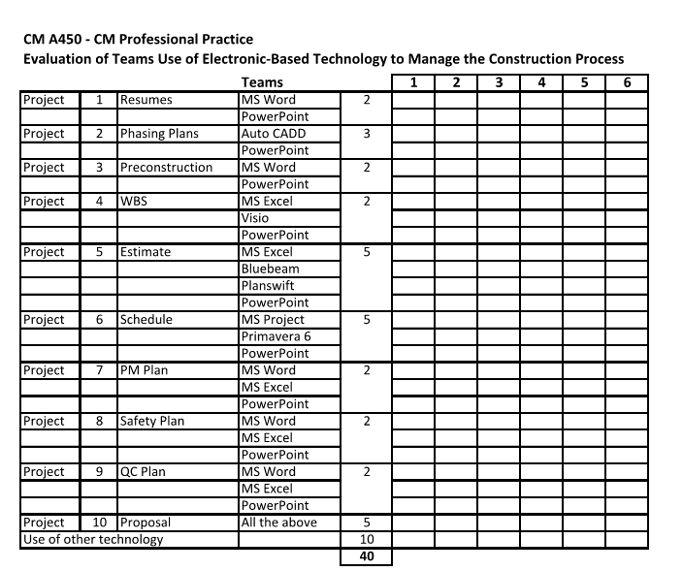

# STUDENT LEARNING OUTCOME 11

**11. Apply basic surveying techniques for construction layout and control.**

11.1 Source Course – GEO A181 – Construction Survey

**Assessment Data 11.1** – Project 4 – Survey Layout

Part I - As a group compute the angles and distances to layout the 4' x 8' rectangle as related to the baseline in the attached .PDF.  
  
Part II - As a group stake out the 4' x 8' rectangle using the angles and distances you computed.

Part III - Measure the 4 sides of the rectangle and the two diagonals as laid out on the ground.

Deliverable: send the instructor your measurements.

Grading: A - perimeter less than 0.10 feet of computed  
 B - perimeter less than 0.25 feet of computed  
 C - perimeter less than 0.40 feet of computed  
 D - perimeter less than 0.50 feet of computed  
 F - perimeter greater than 0.50 feet of computed

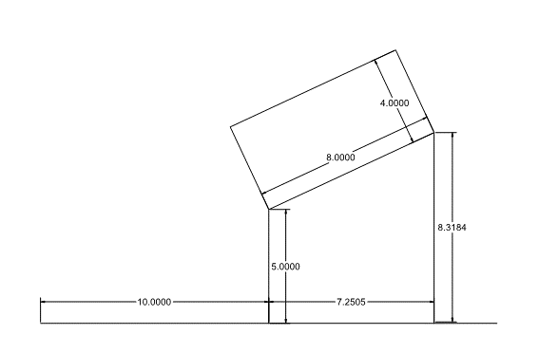

STUDENT LEARNING OUTCOME 11 (Continued)

11.2 Source Course – CM A313 – Civil Technology

**Assessment Data 11.2** - This course outlines the elements of civil design. The students become familiar with all the major design tasks in a civil project: design, material quantities, cost estimation. The students are introduced to construction surveying.

Lab 5: Students layout parcels, size parcels and edit parcels, utilizing basic surveying techniques embedded in the Civil 3D software.

Lab 5 is worth 10 points based on the following rubric.

| **CRITERIA** | **POINTS** |
| --- | --- |
| Process | 2 |
| Accuracy | 2 |
| Completion | 2 |
| Comprehension | 2 |
| Presentation | 2 |

# STUDENT LEARNING OUTCOME 12

**12. Understand different methods of project delivery and the roles and responsibilities of all constituencies involved in the design and construction process.**

12.1 Source Course – CM A301 – Construction Project Management II

**Assessment Data 12.1** -- Team Project 1 for this course provides a project scenario in which student teams acting as a prospective Construction Management Firms provide formal presentations to a fictitious school board for the recommended project delivery system for a new High School project. The students are asked to create a fictional construction management company including stationary with letterhead, a brief statement of the firm’s qualifications, and a list of team members with their various job titles for a construction management firm. The student teams are required to analyze 8 different delivery systems for the new High School project and create a selection matrix that identifies the top three delivery systems. The team’s final deliverables include a Statement of Interest, executive summary with delivery system recommendations, and oral presentation to the fictitious school board.

The executive summary and team member scores for Team Project 1 have a point value of 100 points which is approximately 7 percent of the student’s final grade for this class.

The scores for the above defined portion of the grading rubric are direct measure of each student’s understanding of the different methods of project delivery and the roles and responsibilities of all competencies involved in the design and construction process.

**Grading Rubric**

* Executive Summary and Recommendation (hard copy): 75 points
* Team Member Scores: 25 points

**Total Score 100 Points**

STUDENT LEARNING OUTCOME 12 (continued)

12.2 Source Course – CM A450 – Construction Management Professional Practice

**Assessment Data 12.2** – Project 3 is an identification of preconstruction services appropriate to the subject project. One required preconstruction service is a written report to the owner on the advantages and disadvantages of each potential method of delivery. This a separate mandatory report and is scored separately, but is part of the overall project score. This portion of the project simulates an analysis by a construction management firm before the RFP is issued.

An overall average score on this portion of project 3 of 80% or better demonstrates that the SLO has been met.

Note this element of Project 3 will first be introduced into the course in Fall 2016.

**CM A450 - CM Professional Practice**

**Partial Project 3 - Methods of Delivery Analysis**

**Sand Lake Elementary Renewal**

| **Methods of Delivery Analysis** |  | **1** | **2** | **3** | **4** | **5** | **6** |
| --- | --- | --- | --- | --- | --- | --- | --- |
| **Design-Bid-Build** | 2 |  |  |  |  |  |  |
| **Advantages** | 2 |  |  |  |  |  |  |
| **Disadvantages** | 2 |  |  |  |  |  |  |
| **Design-Build with GMP** | 2 |  |  |  |  |  |  |
| **Advantages** | 2 |  |  |  |  |  |  |
| **Disadvantages** | 2 |  |  |  |  |  |  |
| **CM at Risk with GMP** | 2 |  |  |  |  |  |  |
| **Advantages** | 2 |  |  |  |  |  |  |
| **Disadvantages** | 2 |  |  |  |  |  |  |
| **Integrated Project Delivery** | 2 |  |  |  |  |  |  |
| **Advantages** | 2 |  |  |  |  |  |  |
| **Disadvantages** | 2 |  |  |  |  |  |  |
| **Other methods of variations** | 4 |  |  |  |  |  |  |
|  | **28** |  |  |  |  |  |  |

# STUDENT LEARNING OUTCOME 13

**13. Understand construction risk management.**

13.1 Source Course – CM A205 – Construction Safety

**Assessment Data 13.1 - Students are presented with basic risk management considerations and requirements in accordance with ANSI Z10 Occupational Health & Safety Management Systems.**

There are five (5) questions embedded in the Take-Home Mid-Term exam that specifically address risk identification and mitigation. These five (5) questions are scored collectively to determine if students have met this student learning outcome.

STUDENT LEARNING OUTCOME 13 (continued)

13.2 Source Course – CM A301 – Construction Project Management II

**Assessment Data 13.2** - This course focuses extensively on construction risk management in class lecture #2 “The Construction Business”, lecture 3 “Project Delivery Methods”, and lecture 4 “Project Procurement”.

The students understanding on construction risk management is assessed specifically in Quiz 1. This quiz includes 10 short answer questions on construction risk and has a point value of 25 points. There are 4 quizzes in this course which represent approximately 7 percent of the student’s final grade for this course.

The scores for the above defined portion of the grading rubric are direct measure of each student’s understanding of construction risk management.

**Grading Rubric (Quiz 1)**

* 10 questions-2.5 Points each, short answer. 25 points

**Total Score 25 Points**

# STUDENT LEARNING OUTCOME 14

**14. Understand construction accounting and cost control.**

14.1 Source Course – CM A301 – Construction Project Management II

**Assessment Data 14.1** – This course focuses extensively on construction accounting, cost control, project controls, and job cost accounting in class lecture #6 “Payments and cost/schedule control”.

The students understanding on construction accounting and cost control is assessed specifically in Quiz 2. This quiz includes 10 short answer questions and has a point value of 25 points. There are 4 quizzes in this course which represent approximately 7 percent of the student’s final grade for this course.

The scores for the above defined portion of the grading rubric are direct measure of each student’s understanding of construction accounting and cost control.

**Grading Rubric (Quiz 2)**

* 10 questions-2.5 Points each, short answer. 25 points

**Total Score 25 Points**

STUDENT LEARNING OUTCOME 14 (continued)

14.2 Source Course – CM A440 – Financial Management for Construction

**Assessment Data 14.2** - Presentation Assignment

**Objective-** Students will be assigned a partner and prepare an oral presentation on a construction company of their choice and approved by the instructor. Students should present as if they are presenting to a group of investors that you would like to invest in their construction company so it can grow. As part of the presentation students are expected to explain to the instructor how the company is performing financially. This would include explaining in detail the company’s Balance sheet, Income statement and Statement of Cash Flows. Questions might be based on the following; changes in the balance sheet and was it a source or use of cash to the company or impacts of depreciated equipment, situation with the companies “excess in cost of billings” and “cost in excess of billings”. Income statement analysis indicating trends in performance, their ability to control the companies cost related to projects, cost over runs or Statement of Cash Flows indicating how the company funded a loss or how they used profits for that year. It will be important to use the companies 10K reports to find out the details of your construction company and their accounting procedures.

Students are the construction finance manager of this company. As such they will be expected to know as much as possible about the performance of your company and its accounting procedures. Students will be asked how they would fix the balance sheet issues, procedures and processes they would implement to control cost and improve margins or how they would increase profitability of the company. Be prepared to be asked anything about your construction company.

| **Evaluation Criteria** | **Possible Points** | **Points Earned** |
| --- | --- | --- |
| History of the company  -General Background  -What is their specialty  -Ownership structure | 30 |  |
| Analysis of the Balance sheet  -sources and uses of cash  -Construction billings  -% of depreciated assets  -Large changes from year to year | 40 |  |
| Income Statement analysis  -Large changes from year to year  -Cost control & Monitoring of the company  -Profit or loss? How did they fund a loss? | 40 |  |
| Statement of Cash Flows  -Increase/decrease in cash position  -Did the company borrow funds  -How did the company use profits or fund a loss? | 40 |  |
| Company recommendations | 20 |  |
| Misc. | 30 |  |
| **Total Points:** | 200 |  |

# STUDENT LEARNING OUTCOME 15

**15. Understand construction quality assurance and control.**

15.1 Source Course – CM A301 – Construction Project Management II

**Assessment Data 15.1** – Individual Project 4 for this course requires the students to write a quality control plan for a 5 million dollar commercial project.

The students are given the complete procurement documents, a listing of all subcontractors, and a list of all suppliers for the project. The students are also provided basic information about the company including the average number of projects completed annually, annual volume in dollars, the makeup of the current CM office staff, and construction field personnel.

The fictional company has experienced numerous quality problems. In an effort to turn around the company’s quality problems the student is tasked to write a quality control plan for implementation based on the Corps of Engineers CQC Quality Control/Quality Assurance system. The plan needs to be written so that if successful it will be incorporated into all of the company current and future projects.

This project has a point value of 100 points which is approximately 7 percent of the student’s final grade for this class.

The scores for the above defined portion of the grading rubric are direct measure of each student’s understanding of construction quality assurance and control.

**Grading Rubric**

* The document has a professional appearance and worthy of the

Workplace environment 10 Points

* The Plan well organized. 10 Points
* Grammar & Spelling. 10 Points
* All Quality Control Objectives have been met or addressed. 70 Points

**Total Score 100 Points**

STUDENT LEARNING OUTCOME 15 (continued)

15.2 Source Course – CM A450 – Construction Management Professional Practice

**Assessment Data 15.2** - Project 9 is the creation of a quality assurance / control plan for the subject project. The plan is scored based on the following rubric.

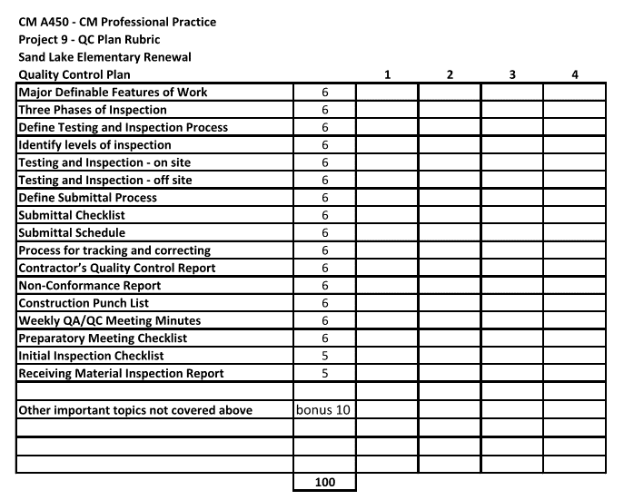

# STUDENT LEARNING OUTCOME 16

**16. Understand construction project control processes.**

16.1 Source Course – CM A301 – Construction Project Management II

**Assessment Data 16.1** - This course focuses on project controls in class lecture #3 “Project Delivery Methods” and class lecture #6 “Payments and cost/schedule control”.

The students understanding on construction project controls is assessed specifically in Quiz 3. This quiz includes 10 short answer questions and has a point value of 25 points. There are 4 quizzes in this course which represent approximately 7 percent of the student’s final grade for this course.

The scores for the above defined portion of the grading rubric are direct measure of each student’s understanding of construction accounting and cost control.

**Grading Rubric (Quiz 3)**

* 10 questions-2.5 Points each, short answer. 25 points

**Total Score 25 Points**

STUDENT LEARNING OUTCOME 16 (continued)

16.2 Source Course – CM A450 – Construction Management Professional Practice

**Assessment Data 16.2** – Project 7 – Construction Management Plan contains procedures for cost control and managing a construction contract. Quality control and time management are addressed in other CM A450 projects.

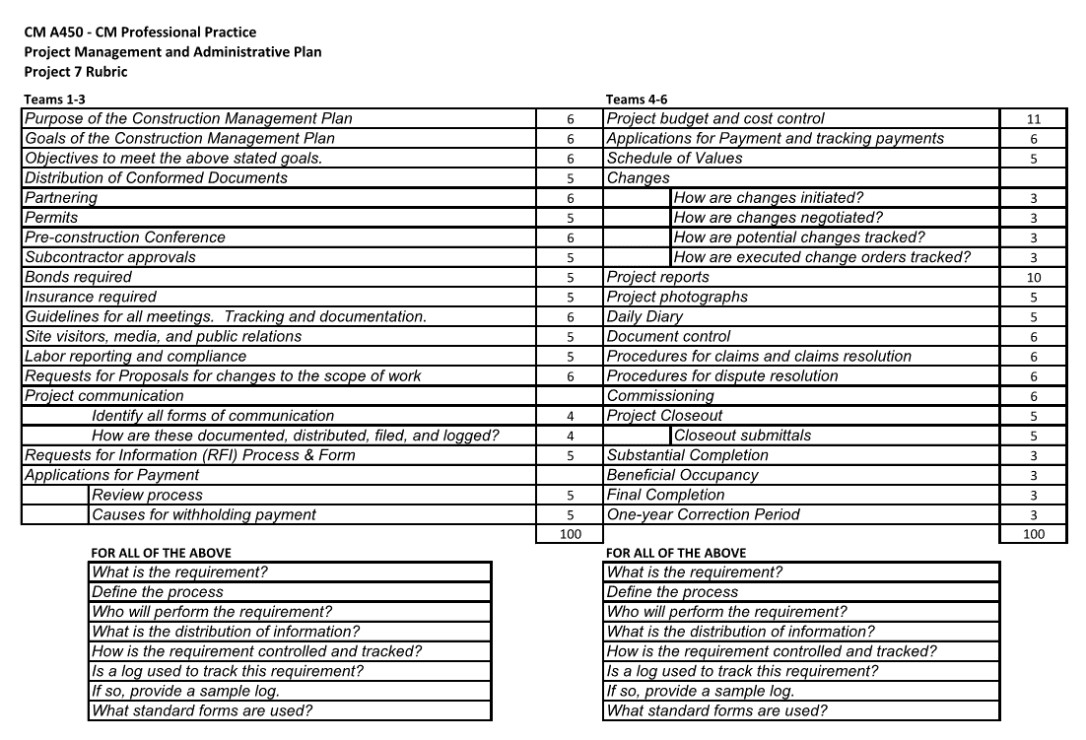

# STUDENT LEARNING OUTCOME 17

**17. Understand the legal implications of contract, common, and regulatory law to manage a construction project.**

17.1 Source Course – CM A301 – Construction Project Management II

**Assessment Data 17.1** - This course focuses on specifically on legal implications of contract, common, and regulatory law in class lecture #13 “Insurance and Bonding”, class lecture #14 “Labor Law and Labor Relations”, and class lecture #15 “Claims and Disputes”.

The students understanding of the legal implications of contract, common, and regulatory law to manage a construction project is assessed specifically in Quiz 4. This quiz includes 10 short answer questions and has a point value of 25 points. There are 4 quizzes in this course which represent approximately 7 percent of the student’s final grade for this course.

The scores for the above defined portion of the grading rubric are direct measure of each student’s understanding of the legal implications of contract, common, and regulatory law to manage a construction project..

**Grading Rubric (Quiz 4)**

* 10 questions-2.5 Points each, short answer. 25 points

**Total Score 25 Points**

17.2 Source Course – CM A401 – Construction Law

**Assessment Data 17.2** -

Assessing a student’s overall understanding of legal principles for the construction industry is best done using the final exam for this course.

Student scores are averaged to identify an average overall score. A percentage is established by dividing the average points for correct responses by the total possible points.

STUDENT LEARNING OUTCOME 17 (Continued)

17.3 Source Course – AET A123 – Codes and Standards

**Assessment Data 17.3** - This entire course is based on the Municipality of Anchorage Title 21 (Land Use), the 2012 International Building Code, and associated codes which is regulatory law. The final exam has includes 25 regulatory law questions and problems based on the 2012 IBC.

The final exam has a point value of 100 points which is approximately 13 percent of the student’s grade for the course.

The scores for the final exam are direct measure of each student’s understanding of the implications of regulatory law to manage a construction project.

**Grading Rubric**

Final Exam 25 Questions 100 Points

**Alternative Assessment 17.3** There is no final exam. A final project of a code analysis for a proposed structure, as presented in a construction document set, is prepared by the student. The code analysis incorporates elements of the Title 21 and the IBC that include: Zoning districts; Setbacks; Parking; Accessibility for parking, access, and operations; Landscaping requirements; Construction types classification; Height and area limitations and modifications; Occupancy use; Means of egress; Fire resistance ratings for components and assemblies; and Special inspection requirements.

The code analysis is prepared by listing: Existing conditions for each category, cite code required conditions with references, and recommendations for compliance where deficiencies in the design are recognized. Students also edit the construction documents to show the ‘worst case scenario’ for path of egress, location of alarms, exit signs, a fire control center, and emergency lighting. The project comes from their own design results in the AET A121 Architectural Drawing class or a student designed building for the theoretical UAA School of Architecture.

There is a scoring sheet and the value of the project is 100 out of a total of 2000 points possible for the class.

# STUDENT LEARNING OUTCOME 18

**18. Understand the basic principles of sustainable construction.**

18.1 Source Course – AET A102 - Methods of Building Construction

**Assessment Data 18.1 -** Research Assignment 1 is an investigation into how the construction industry uses recycled or reused building materials. Students are asked to choose a type of building material and research issues such as who uses the material and why, where in a building the material is used, what the material does for the sustainable qualities of the building and the environment, which buildings use the material, and provide a critical analysis of the benefits of using recycled or reused building material instead of new material.

The assignment is worth 100 points based on the following rubric:

| **CRITERIA** | **POINTS** |
| --- | --- |
| Punctuality | 20 |
| Organization | 20 |
| Clarity | 20 |
| Depth of Investigation | 20 |
| Grammar / Spelling | 20 |

STUDENT LEARNING OUTCOME 18 (continued)

18.2 Source Course – AET A102 – Methods of Building Construction

**Assessment Data 18.2** - Research Assignment 2 is an investigation into organizations that set standards and certify products in the construction industry that are sustainable and environmentally responsible. Students must research the Forest Stewardship Council, ISO 14000, Greenguard Environmental Institute, Green Label and Green Label Plus, and Green Seal. These organizations provide information and resources that help guide the designer and builder towards products that are environmentally safe and ecologically sustainable.

The assignment is worth 100 points based on the following rubric:

| **CRITERIA** | **POINTS** |
| --- | --- |
| Punctuality | 20 |
| Organization | 20 |
| Clarity | 20 |
| Depth of Investigation | 20 |
| Grammar / Spelling | 20 |

# STUDENT LEARNING OUTCOME 19

**19. Understand the basic principles of structural behavior.**

19.1 Source Course – CM A231 – Structural Technology

**Assessment Data 19.1** -

Test 3:

*Statics and Strengths of Materials* applies quantitative analysis skills developed in General Education classes to understand and analyze the structural dynamics of building systems. Trigonometric principles are used in the analysis of vectors to find resultant forces in structural systems subjected to complex force configurations. Test 3 evaluates students’ ability to apply vector resolution to the analysis of trusses and pinned framed structures subjected to dynamic forces, tracing loads and calculating forces throughout structures. These principles are later applied in the analysis of temporary structures such as scaffolds and concrete formwork.

Test 3 is worth 100 points based on the following rubric. A score of 75% and above is considered to have met student learning outcomes.

| **CRITERIA** | **POINTS** |
| --- | --- |
| Process | 20 |
| Accuracy | 20 |
| Completion | 20 |
| Comprehension | 20 |
| Presentation | 20 |

STUDENT LEARNING OUTCOME 19 (continued)

19.2 Source Course – CM A331 – Statics and Strengths of Materials

**Assessment Data 19.2** -

Test 3:

*Statics and Strengths of Materials* applies quantitative analysis skills developed in General Education classes to understand and analyze the structural dynamics of building systems. Trigonometric principles are used in the analysis of vectors to find resultant forces in structural systems subjected to complex force configurations. Test 3 evaluates students’ ability to apply vector resolution to the analysis of trusses and pinned framed structures subjected to dynamic forces, tracing loads and calculating forces throughout structures. These principles are later applied in the analysis of temporary structures such as scaffolds and concrete formwork.

Test 3 is worth 100 points based on the following rubric. A score of 75% and above is considered to have met student learning outcomes.

| **CRITERIA** | **POINTS** |
| --- | --- |
| Process | 20 |
| Accuracy | 20 |
| Completion | 20 |
| Comprehension | 20 |
| Presentation | 20 |

# STUDENT LEARNING OUTCOME 20

**20. Understand the basic principles of mechanical, electrical and piping systems.**

20.1 Source Course – CM A142 – Mechanical and Electrical Technology

**Assessment Data 20.1** -

Project 5:

*Mechanical and Electrical Technology* introduces students to the basic concepts, processes, and fundamentals of mechanical and electrical systems common to all buildings. Project 5 focuses on the fluid mechanics associated with water supply systems and the principles used in determining drain, waste, and vent (DWV) requirements. It requires students to calculate water supply pipe requirements based on municipal water supply pressure. Students must reference the Uniform Plumbing Code (UPC) to determine the number of Water Supply Fixture Units associated with supply lines to calculate pipe sizes. Students must also use the UPC to determine the Drainage Fixture Units used to calculate DWV requirements. Calculations are presented in AutoCAD as a Mechanical Plan layout.

Project 5 is worth 80 points based on the following rubric. A score of 75% and above is considered to have met student learning outcomes.

| **CRITERIA** | **POINTS** |
| --- | --- |
| Process | 20 |
| Accuracy | 20 |
| Completion | 20 |
| Comprehension | 20 |
| Presentation | 20 |

STUDENT LEARNING OUTCOME 20 (continued)

20.2 Source Course – CM A142 – Mechanical and Electrical Technology

**Assessment Data 20.2** -

Final Exam:

*Mechanical and Electrical Technology* introduces students to the basic concepts, processes, and fundamentals of mechanical and electrical systems common to all buildings. The Final Exam covers material primarily associated with electrical systems. Students must be able to differentiate between series and parallel circuits, AC and DC power, calculate amps, volts, watts, and power within electrical circuits, explain how electrical components (such as GFCI receptacles, single pole, double pole, 3-way & 4 way switches, and transformers) work, explain the types and relative efficiencies of various lamps, demonstrate the use of National Electrical Code tables to determine safe wire sizes, and calculate demand and power usage, applying local electrical utility billing rates.

The Final Exam is worth 188 points. A score of 75% and above is considered to have met student learning outcomes.