**University of Alaska Anchorage logo**

**AAS GBUS**

**Academic Assessment Plan**

**Adopted Jointly by**

**The UAA, MSC, KOC, KPC Faculty**

**April 15, 2024**

Reviewed by the college committee: 4/24/24

Reviewed by the dean: 4/24/24

Reviewed by the Academic Assessment Committee: 5/3/24

Reviewed by the Faculty Senate as an information item: 5/3/24

Table of Contents

COLLEGE MISSION STATEMENT 3

PROGRAM MISSION STATEMENT 3

PROGRAM INTRODUCTION 3

ASSESSMENT PROCESS INTRODUCTION 4

AAS GBUS COMPETENCY GOALS 4

Table 1 – AAS GBUS Competency Goals and Learning Objectives 4

STUDENT SUCCESS RATE GOAL 5

ASSESSMENT IMPLEMENTATION & ANALYSIS FOR PROGRAM IMPROVEMENT 5

ASSESSMENT TIMETABLE 6

APPENDIX A: AAS GBUS CURRICULUM MAPPING 8

APPENDIX B: EXAMPLES OF ASSESSMENT DATA COLLECTION DOCUMENTS 9

# College Mission Statement

The College of Business and Public Policy at the University of Alaska Anchorage prepares students for leadership at the frontiers of a changing world. We help diverse and growing communities in Alaska and elsewhere meet their challenges by delivering the highest quality in business and public policy education, research, and professional assistance.

# Program Mission Statement

The AAS in General Business provides students with knowledge and fundamental principles of business and non-profit organizations to support students’ application of professional and entrepreneurial skills.

# Program Introduction

The University of Alaska Anchorage (UAA) and its extended campuses Matanuska-Susitna College (MSC), Kenai Peninsula College (KPC), and Kodiak College (KOC) are accredited through the Northwest Commission on Colleges and Universities (NWCCU).

The Associate of Applied Science Degree in General Business (AAS GBUS) is a two-year program designed to prepare students for immediate employment in the business administration environment. The program may also be used as a foundation for students who wish to pursue a bachelor’s degree at a later date, although not all courses or credits in this program will transfer into the four-year program. The emphasis of the program is to provide students with practical, job-oriented skills utilizing current technologies found in the workplace.

The AAS GBUS program consists of the following courses:

**Major Requirements** (36 credits):

Students must complete the following required courses with a grade of C or better:

ACCT A201 Principles of Financial Accounting ** 3

ACCT A202 Principles of Managerial Accounting 3

BA A151 Business Foundations 3

BA A166 Entrepreneurship and Small Business Management 3

BA A231 Fundamentals of Supervision 3

BA A233 Survey of Finance 3

BA A241 Business Law I 3

BA A260 Marketing Practices 3

BADA A110 Computer Concepts in Business 3

ECON A101 Principles of Microeconomics 3

ECON A102 Principles of Macroeconomics 3

LGOP A110 Logistics, Information Systems and Customer Service 3

Complete 9 credits of advisor-approved electives. Courses must be from: ACCT, BA, BADA, ECON, LGOP or LOG

** *The*[*ACCT A101*](https://nextcatalog.uaa.alaska.edu/search/?P=ACCT%20A101)*and*[*ACCT A102*](https://nextcatalog.uaa.alaska.edu/search/?P=ACCT%20A102)*sequence may be used to satisfy the*[*ACCT A201*](https://nextcatalog.uaa.alaska.edu/search/?P=ACCT%20A201)*requirement for this degree.*

*\*\*\** Advisor approval is required for all electives

A minimum of 60 credits is required for the degree.

# Assessment Process Introduction

The purpose of this document is to provide a guide for jointly assessing the overall academic effectiveness of the AAS GBUS degree program at UAA, MSC, KPC, & KOC. This document addresses the needs of accreditors, administrators, external stakeholders, students, and faculty. Accreditors set general standards, including the requirement that actual results agree with the stated mission. Administrators are accountable for program effectiveness and need to know whether the program is delivering promised learning outcomes. External stakeholders value the program’s effectiveness and also require and deserve empirical assurance of learning. Students need to know what they can reasonably expect to achieve from their investment of time and money in the AAS GBUS program. The faculty is responsible for instructional effectiveness and for making continuous improvements to the program based on the analysis of collected assessment data.

# AAS GBUS Competency Goals

Competency goals articulate what graduates should be able to do and/or what overall traits they should possess at the conclusion of the AAS GBUS program. Competency goals will be supported by direct and/or indirect measurable learning objectives. Learning objectives specify actions for describing, monitoring, and assessing student achievements. Hence, learning objectives are used to represent competency goals.

Upon graduation, AAS GBUS program graduates will possess the following skills as defined by these AAS GBUS Competency Goals:

1. Students will have knowledge of business concepts.
2. Students will have knowledge of the impact of business on society.
3. Students will have basic business quantitative skills.
4. Students will have business communication skills.

## Table 1 – AAS GBUS Competency Goals and Learning Objectives

| **Goal 1 – Students will have knowledge of business concepts.** |
| --- |
| Objective 1.1 – Convey knowledge of business concepts and applications. |
| **Goal 2 – Students will have knowledge of the impact of business on society.** |
| Objective 2.1 – Illustrate knowledge of how business practices impact society. |
| **Goal 3 – Students will have basic business quantitative skills** |
| Objective 3.1 – Apply quantitative techniques to solve business problems. |
| **Goal 4 – Students will have business communication skills.** |
| Objective 4.1 – Demonstrate proficient oral and/or written communication skills. |

# Student Success Rate Goal

In AY 2021-2022 and years prior, our goal was that 70% of students would successfully demonstrate achievement of learning objectives.

Starting in AY 2022-2023, we have increased our goal to 75%.

From AY 2022-2028, we plan to incrementally increase the successful percentage from 75% to 80%, which is a 10-percentage point increase over 7 years.

If the percentage of students successfully demonstrating achievement of learning objectives equals the percentages above, they will have met expectations. Anything exceeding these percentages means the students will have exceeded expectations.

# Assessment Implementation & Analysis for Program Improvement

**General Management of Assessment Activities**

The assessment activities are managed through CBPP Assurance of Learning (AoL) Committee that is comprised of a faculty member and the associate dean (ex-officio).

**General Implementation Strategy**

The CBPP AoL Committee is responsible for overseeing the assessment process.

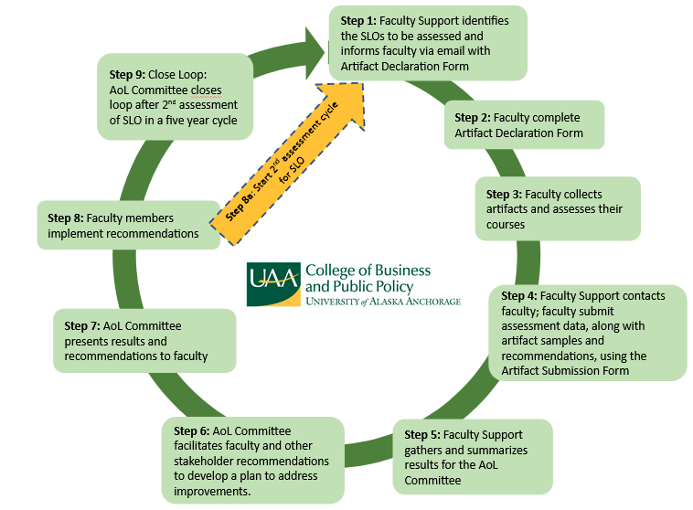

# Assessment Timetable

1. Faculty whose course is scheduled for assessment are contacted at the beginning of each semester and informed about the competency goals and learning objective(s) that will be assessed for the semester. They provide information about their assignment and assessment tool.
2. Faculty Support collects assessment data and sample artifacts. Faculty are responsible for mapping questions or other assignments that align with the learning objective(s). Faculty also submit recommendations related to their courses.
3. The CBPP AoL Committee, with the assistance of Faculty Support, compiles and analyzes collected data.
4. The AoL Committee discusses assessment results with faculty and if applicable, the CBPP Curriculum Committee.
5. The AoL Committee and faculty make recommendations for the instructor to implement. This information is shared with other stakeholders, e.g., Chairs, Director of Graduate Programs, Dean’s Office, and other faculty.
6. The process will repeat for a second cycle and the loop will be closed after the second cycle. AACSB requires the assessment of competency goals twice and the loop to be closed once in a five-year period.
7. The Chair of the AoL Committee submits an Academic Assessment Report to the CBPP Dean’s Office for review and submission to the Office of Academic Affairs (OAA).
8. The AoL Committee presents data analysis and recommendations at an all-College meeting.

Proposed program changes may be any action or change in policy the faculty deems as being necessary to improve performance relative to learning objectives. Recommended changes should also consider workload (faculty, staff, and students), budgetary, facilities, and other relevant constraints. A few examples of changes made by programs at UAA include:

* Changes in course content, scheduling, sequencing, prerequisites, delivery methods, etc.
* Changes in faculty/staff assignments
* Changes in advising methods and requirements
* Addition and/or replacement of equipment
* Changes to facilities

The CBPP Dean’s Office and college staff are responsible for:

* Providing sufficient financial support for the development and implementation of this plan.
* Ensuring that faculty assessment efforts are appropriately reflected in annual workload agreements.

The AAS GBUS faculty is responsible for:

* Undertaking assessment efforts as an integral portion of teaching activity.
* Participating in meetings to discuss assessment data and offer recommendations for program improvement.

**Modification of the Educational Effectiveness Assessment Plan**

The AAS GBUS faculty, after reviewing the collected data and the processes used to collect it, may decide to alter this assessment plan. This plan will be reviewed and updated as needed every five to seven years as recommended by the UAA Faculty Senate Academic Assessment Committee. Changes may be made to any component of the plan, including the goals, objectives, assessment tools, collection methods, or any other aspect of the plan. Any changes are to be approved by the faculty of the program. A modified assessment plan will be forwarded to the CBPP Dean and the UAA Office of Academic Affairs.

# Appendix A: AAS GBUS Curriculum Mapping

Learning objectives are aligned with the AAS GBUS Objectives.

| **AAS GBUS COURSE MAPPING** | | | | |
| --- | --- | --- | --- | --- |
|  | Goal 1 | Goal 2 | Goal 3 | Goal 4 |
|  | Obj. 1.1 | Obj. 2.1 | Obj. 3.1 | Obj. 4.1 |
| BA A151 Business Foundations | x |  |  |  |
| BA A166 Entrepreneurship and Small Business Management |  |  |  | x |
| BA A241 Business Law I |  |  |  | x |
| ACCT A201 Financial Accounting |  |  | x |  |
| ACCT A202 Managerial Accounting |  |  | x |  |
| ECON A101 Microeconomics |  | x |  |  |
| ECON A102 Macroeconomics |  | x |  |  |
| BADA A110 Computer Concepts in Business |  |  | x |  |

| **Goal 1 – Students will have knowledge of business concepts.** |
| --- |
| Objective 1.1 – Convey knowledge of business concepts and applications. |
| **Goal 2 – Students will have knowledge of the impact of business on society.** |
| Objective 2.1 – Illustrate knowledge of how business practices impact society. |
| **Goal 3 – Students will have basic business quantitative skills** |
| Objective 3.1 – Apply quantitative techniques to solve business problems. |
| **Goal 4 – Students will have business communication skills.** |
| Objective 4.1 – Demonstrate proficient oral and/or written communication skills. |

# Appendix B: Examples of Assessment Data Collection Documents

**COLLEGE OF BUSINESS AND PUBLIC POLICY**

**ASSURANCE OF LEARNING (AoL)**

**ANNUAL ASSESSMENT REPORTING TEMPLATE**

**Please indicate which of the AAS GBUS Competency Goals and Learning Objective(s) you are reporting on and submit assessment data for:**

* [Insert AAS GBUS Competency Goal]
* [Insert AAS GBUS Learning Objective(s)]

**Please indicate in which COURSE data was collected. (EXAMPLE BA A151 Business Foundations)**

* [Insert Course]

**In which SEMESTER was the data collected? (i.e., summer 2025, fall 2026, spring 2026)**

* [Insert Semester]

**How many student artifacts were evaluated?**

* [Insert Number of Student Artifacts]

**Of the student artifacts evaluated, how many were rated as:**

* Exceeds: [Insert Number]
* Meets: [Insert Number]
* Does Not Meet: [Insert Number]
* Total Number: [Insert Total]

**Describe your benchmark for determining a successful or unsuccessful artifacts:**

* [Insert Response]

**Identify the assessment method and provide a copy of the assessment tool (i.e., exam [exam questions], activity, exercise, project, etc.).**

* [Insert Response]

**As course instructor, were you satisfied with student performance and learning as related to the Learning Goal(s) and Objective(s) being assessed? Provide rationale for the selection.**

* [Select Yes or No]
* [Insert Rationale for Selection]

**What can you, your department, or the College do to improve student performance and/or learning in future offerings of this course?**

* [Insert Response]

**Please also attach the following with your submission of this template (attach in email response).**

* **Rating/grading rubric for evaluating student performance and/or student artifacts.**