**UAA logo**

**Associate of Applied Science in**

**Radiologic Technology**

**Academic Assessment Plan**

**Adopted by**

**The Radiologic Technology Faculty: December 2020**

Reviewed with curriculum by the college committee: 4/19/24

Reviewed with curriculum by the dean: 4/22/24

Reviewed with curriculum by the Academic Assessment Committee as an information item: 5/3/24

Reviewed by the Faculty Senate as an information item: 5/3/24

Reviewed with curriculum changes by the Academic Assessment Committee as an information item: 12/2/22

Reviewed by the Faculty Senate as an information item: 12/22/22

Reviewed by the Academic Assessment Committee: 4/2/21

Reviewed by the Faculty Senate as an information item: 4/2/21

# Mission Statement

The Mission of the *Medical Imaging Science Department* program in Radiologic Technology is to prepare individuals to become knowledgeable, competent, caring, and ethical entry-level healthcare professionals based on scientific principles, technical expertise, clinical experience, sound judgment, and responsible professional conduct.

# Program Student Learning Outcomes (PSLO)

Students graduating with an Associate of Applied Science in Radiologic Technology will be able to demonstrate the following:

* Demonstrate proficiency and competency in the performance of radiographic procedures utilizing proper exposure techniques.
* Apply entry-level knowledge and skills as a radiologic technologist.
* Demonstrate a professional attitude and proper ethical behavior in clinic settings.
* Utilize effective oral and written communication with patients, physicians, and other healthcare providers.

# RELATED INSTRUCTION

Students in the Radiologic Technology (RADT) program build knowledge required

to perform specific tasks while they develop communication, computation, and human interaction skills. Radiologic Technology students develop communication and writing skills through required courses. Students obtain quantitative skills through MATH A105 Intermediate Algebra or higher.

Students further develop communication, quantitative and human relations skills within the Radiologic Technology courses. These skills include formulating exposure factors and determining patient dose (quantitative), interacting with peers, patients, and healthcare team members (communication and human relations).

Industry standards for accreditation related to SLO’s will be discussed in this assessment plan. These industry standards are not necessarily a competency or skill a student must demonstrate, but a means of supporting students in a specific SLO.

In the fall of 2020 and spring of 2021, the program will resume sending graduate, industry and employee surveys. In the past, these types of surveys have not produced valid statistical information due to low return rates. After many discussions, faculty have determined that the program needs to try to again. Information from these surveys will be incorporated into the narrative of the annual assessment but not become part of the formal assessment plan until it is determined that the information will provide valid statistical information for program improvement. In order to help achieve a higher return rate, industry and employee surveys will be completed during advisory committee meetings.

# Measures

|  |  |  |  |  |  |  |
| --- | --- | --- | --- | --- | --- | --- |
| Outcomes | American Registry of Radiologic Technologists (ARRT) Canidae Exam Results  Content Category –  Image Production | ARRT Annual Program Summary Report | ARRT National Comparison Report | ARRT Applicant Status | Exit Surveys | Clinical  bi-semester evaluations |
| Demonstrate proficiency and competency in the performance of radiographic procedures utilizing proper exposure techniques. | 1 | 0 | 0 | 0 | 1 | 1 |
| Apply entry-level knowledge and skills of a radiologic technologist. | 0 | 1 | 1 | 1 | 1 | 1 |
| Demonstrate a professional attitude and proper ethical behavior in clinic settings. | 0 | 0 | 0 | 0 | 1 | 1 |
| Utilize effective oral and written communication with patients, physicians, and other healthcare providers. | 0 | 0 | 0 | 0 | 1 | 1 |

0 = Measure is not used to measure the associated outcome.

1 = Measure is used to measure the associated outcome.

# Process

|  |  |  |  |  |
| --- | --- | --- | --- | --- |
| **Measure** | **Description** | **Frequency/ Start Date** | **Collection Method** | **Administered by** |
| American Registry of Radiologic Technologists (ARRT) Candidate Exam Results  Content Category –  Image Production | National registry examination administered by the ARRT | Annually May through July | Available on the ARRT web site for Program Directors | ARRT  Program Director reviews results |
| ARRT Annual Program Summary Report | National registry examination report of the ARRT | Annually May through July | Available on the ARRT web site for Program Directors | ARRT  Program Director reviews results |
| ARRT National Comparison Report | National registry examination report of the ARRT | Annually May through July | Available on the ARRT web site for Program Directors | ARRT  Program Director reviews results |
| ARRT Applicant Status | National registry examination report of the ARRT | Annually May through July | Available on the ARRT web site for Program Directors | ARRT  Program director reviews results |
| Exit Surveys  Program  Clinical | Two student exit surveys used to assess student overall satisfaction of their educational experience. | Annually in April | Annual anonymous surveys through an online format at the end of spring semester | Program director |
| Bi-Semester Evaluations | Evaluation tool of student performance and behavior during clinical rotation. | Midterm and final semester schedule | Submitted to faculty | Clinical Educators |

General Implementation Strategy

The Radiologic Technology Program utilizes six assessment tools of student learning outcomes identified above.

The Radiologic Technology Program utilizes two resources for the eight assessment tools:

1. The American Registry of Radiologic Technologists (ARRT)
   1. ARRT Candidate Exam Results Content Category – Image Production (Example - Appendix A)
   2. ARRT Annual Program Summary Report (Example – Appendix B)
   3. ARRT National Comparison Report (Example – Appendix C)
   4. ARRT Applicant Status – Student names are found on this report. Due to FERPA, an example is not given
2. UAA Radiologic Technology Program
   1. Semester evaluations (Example – Appendix D)
   2. Exit survey (Example – Appendix E)

**Data Assessment**

The program assessment is associated with student cohorts. Data collection occurs over four semesters when students are completing the practicum requirements. Students receive assessment throughout the rotation through the submission of required clinical forms. The Program Director and Clinical Coordinator will analyze the data and provide a report to include any recommendations; for example:

* Changes in course content, scheduling, sequencing, prerequisites, delivery methods, etc.
* Changes in program requirements.
* Addition and/or replacement of equipment.
* Changes to facilities.

**Assessment Reporting**

The program will complete an Academic Assessment Survey and Academic Assessment Report

annually. The report will include any changes or additions to the program, expected

improvements of the changes or additions, the SLOs measured, data collection and analysis,

recommendations based on the findings and other relevant information. The Program Director

will complete the Academic Assessment Survey and submit the Academic Assessment Report as required.

**Assessment Revision**

The Program Director will meet with faculty, advising committee, clinical educators, and the clinical coordinator at least once a year to review the accuracy, currency, and the effectiveness of each measure in the assessment plan. The program director is responsible for making all minor and major changes to the assessment.

**Benchmarks**

Benchmarks are found on the reporting form.

**Industry standards**

The following industry standards are internally assessed by the program. These standards support student learning outcomes and are viewed by both the ARRT and the American Society of Radiologic Technologists (ASRT) as accreditation standards.

* SLO #2: Apply entry-level knowledge and skills as a radiologic technologist.
  + Provides valid clinical experiences for each admitted student.
  + Provides a variety of clinical experiences for each admitted student.
  + Provides a competency-based curriculum.
  + Limits clinical to no more than 10 hours per day and no more than 40 hour per week for each admitted student.
  + Provides access to student services in support of student learning.
* SLO #3 and #4:
  + Assures confidentiality of student records and appropriate program materials.
  + Assures integrity of distance education courses.
  + Provides access to university grievance procedure to each admitted student.
  + Provides current program policy and procedure manual to each admitted student.
  + Provides up to date information on admission policies, tuition/fees, clinical obligations and graduation requirements to students, faculty, administrators and the general public.
  + Provides university, college and program mission statements and goals to students, faculty, administrators and the general public.
  + Provides student learning outcomes to students, faculty, administrators and the general public.

Industry standards will be assessed by several internal methods. Some include, but are not limited to:

* Annual review and update of program policy and procedures manual.
* Review and update, as needed, of web site and catalog program copy.
* Review and update, as needed, course objectives.
* Review student clinical assignment schedules.
* Review of student clinical records.
* Review of other published institution and program materials, as needed.

**Reporting form:**

**SLO #1:** Demonstrate proficiency and competency in the performance of radiographic procedures utilizing proper exposure techniques.

| Measurement tool | Benchmark | Outcome | Trends | Action taken |
| --- | --- | --- | --- | --- |
| ARRT exam results for Image Production category content | Five-year scaled score average of 75% |  |  |  |
| Program clinical exit survey  question #2 | Five-year trend set at 75% for either strongly agree/agree or excellent; very high/above average in student responses |  |  |  |
| Semester evaluations:  occupational skills category | Five-year trend set at an average of rating of three (3.0) |  |  |  |

**SLO #2:** Apply entry-level knowledge and skills as a radiologic technologist.

| Measurement Tool | Benchmark | Outcome | Trends | Action taken |
| --- | --- | --- | --- | --- |
| ARRT Annual Program Summary Report | Five-year scaled score average of 75% |  |  |  |
| ARRT National Comparison Report | Five-year scaled score average of 75% |  |  |  |
| ARRT Applicant Status | Five-year first-time attempt pass rate of 75%;  Five-year pass rate of 75% to include subsequent attempts |  |  |  |
| Clinical exit survey  Program exit survey all questions | Five-year trend set at 75% for either strongly agree/agree or excellent; very high/above average in student responses |  |  |  |
| Semester evaluations:  occupational skills and critical thinking/judgement | Five-year trend set at an average of rating of three (3.0) for all students |  |  |  |

**SLO #3:** Demonstrate a professional attitude and proper ethical behavior in clinic settings.

| Measurement Tool | Benchmark | Outcome | Trends | Action taken |
| --- | --- | --- | --- | --- |
| Clinical exit survey question #3 | Five-year trend set at 75% for either strongly agree/agree or excellent; very high/above average in student responses |  |  |  |
| Semester Evaluations:  professional conduct, patient care,  and critical thinking/judgement | Five-year trend set at an average of rating of three (3.0) for all students |  |  |  |

**SLO #4:** Utilize effective oral and written communication with patients, physicians, and other healthcare providers.

| Measurement Tool | Benchmark | Outcome | Trends | Action Taken |
| --- | --- | --- | --- | --- |
| Program clinical exit survey  question #6, 7 and 8 | Five-year trend set at 75% for either strongly agree/agree or excellent; very high/above average in student responses |  |  |  |
| Semester evaluations:  interpersonal communication skills | Five-year trend set at an average of rating of three (3.0) for all students |  |  |  |

# Appendix A

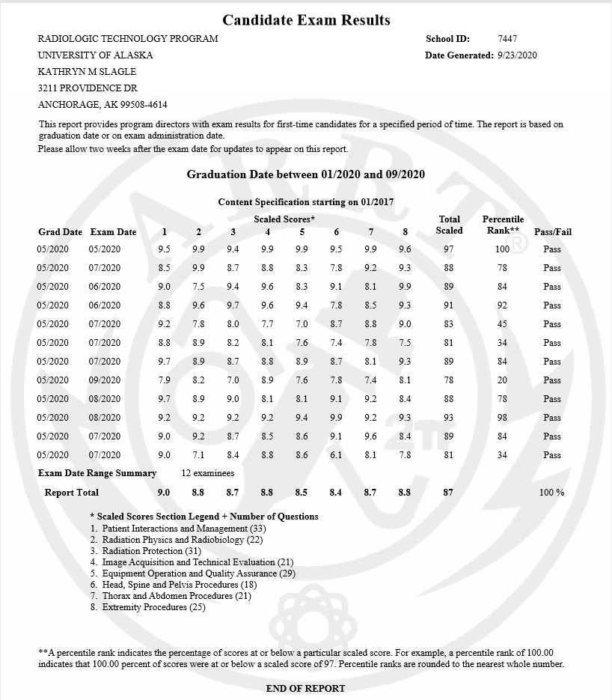

# Appendix B

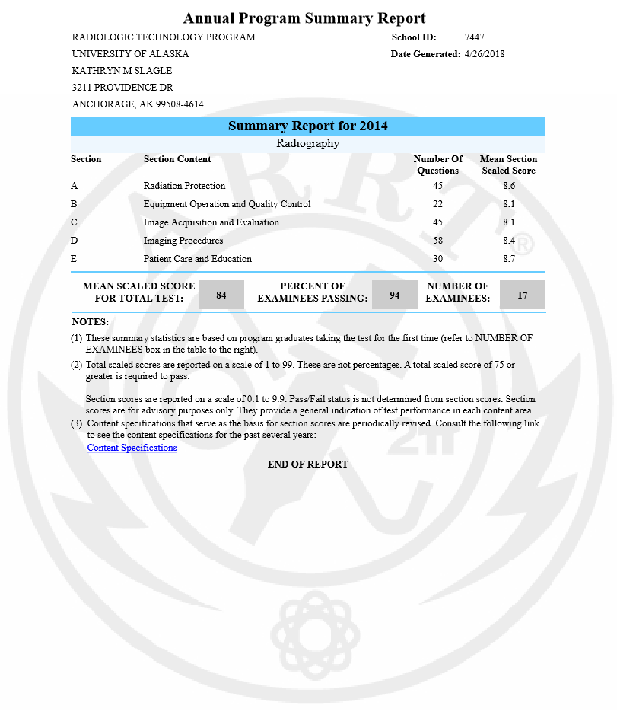

# Appendix C

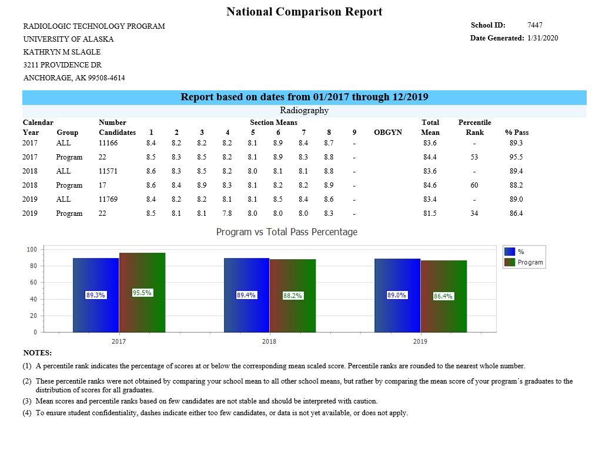

# Appendix D

Areas related to a student outcome have been highlighted a specific color to reference to the SLO.

| SLO |
| --- |
| 1. Demonstrate proficiency and competency in the performance of radiographic procedures utilizing proper exposure techniques. |
| 1. Apply entry-level knowledge and skills as a radiologic technologist. |
| 1. Demonstrate a professional attitude and proper ethical behavior in clinic settings. |
| 1. Utilize effective oral and written communication with patients, physicians, and other healthcare providers. |

| **CATEGORY** | **EXCEPTIONAL**  **(5)** | **ABOVE AVERAGE**  **(4)** | **AVERAGE**  **(3)** | **MARGINAL**  **(2)** | **UNSATISFACTORY (1)** |
| --- | --- | --- | --- | --- | --- |
| **ATTENDANCE** | Consistently reports early and always prepared for the clinic day  **No absences** throughout the evaluation period | Usually reports early and always prepared for the clinic day  **No** **unexcused** absences or tardiness | Reports on time and is usually prepared for the clinic day  N**o more than 2 excused** absences  **No unexcused absences** or tardiness. | **1 or 2 unexcused** absences or tardiness and often not prepared for clinic day  Sometimes leaves clinic area without approval | **More than 2 unexcused** absences  Often leaves clinic area without approval  Has not fulfilled required clinic hours |
| **PROFESSIONAL CONDUCT** | Sets the example of professional conduct, appearance and personal hygiene  Thoroughly understands and follows policy manual and all clinical procedures/guidelines | Consistently adheres to policy manual and clinical procedures  Displays professional conduct and appearance at all times.  Excellent personal hygiene standards | Adheres to policy manual and clinical procedures most times.  Professional most of the time, requires little corrective feedback  Acceptable personal hygiene standards | Has difficulty following policy manual and clinical procedures and/or often requires corrective feedback  Marginal personal hygiene standards | Does not comply with clinical or policy manual requirements  Unacceptable personal hygiene standards  Does not display professional behavior |
| **INTERPERSONAL COMMUNICATION SKILLS** | Exemplary communication skills  Relates exceptionally well with staff and peers  Willingly accepts constructive criticism | Highly effective communication skills  Consistently relates and communicates well with staff and peers  Accepts constructive criticism | Acceptable communication skills  Communicates well with staff and peers  Acceptable to constructive criticism | Marginal Communication skills  Has difficulty interacting with staff and peers; can be defensive or make excuses | Does not or seldom relates and/or communicates well with staff and peers  Unacceptable to criticisms. Defensive and makes excuses |
| **ORGANIZATIONAL SKILLS** | Exhibits exceptional degree of proficiency performing daily tasks  Clinic manual/materials always neat, organized and readily available  Performs at exceptional level without assistance | Very proficient in performing daily tasks  Clinic manual/materials always neat, organized and readily available  Performs at high level in clinic setting with little assistance | Performs daily tasks effectively  Clinic manual/materials usually in good order and available  Performs well in clinic setting with occasional guidance | Has difficulty performing daily tasks in organized manner  Clinic manual/materials require attention  Not well organized in thoughts or performance | Lacks display of organizational skills  Does not maintain clinic manual or materials properly  Lacks organizational motivation |
| **Occupational Skills**  **(consistent to level of training)** | Excels in all areas related to clinical standard operating procedures and policies  Formulates techniques with no assistance  Performs exams proficiently with few repeats  Exceptional progress toward clinical requirements | Knows clinical standard operating procedures and policies  Formulates most techniques without assistance  Performs exams in a timely manner with few repeats  Exceeds expected progress toward clinical requirements | Knows most clinical standard operating procedures and policies  Formulates techniques with some assistance  Usually completes exams in a timely manner  Acceptable progress towards clinical requirements | At times fails to abide by clinical standard operating procedures and policies  Often fails to formulate techniques without assistance  Fails to complete exams in a timely manner or has excessive repeats | Fails to abide by clinical standard operating procedures and policies  Does not display adequate skillset required to perform patient exams  Unsatisfactory progress towards clinical requirements |
| **PATIENT CARE** | Exemplary display of patient care skills  Exceptional ability to establish rapport with patients and creates compassionate, caring atmosphere  Able to adapt to patients’ mental and physical status without assistance | Highly skilled in patient care  Establishes positive relationship with patients consistently perceives patient’s status, creates a compassionate, caring atmosphere.  Able to adapt to patients’ mental and physical status with little assistance | Effective patient care skills  Student able to perceive patient’s status creates a compassionate, caring, friendly atmosphere.  Able to adapt to patients’ mental and physical status with occasional assistance | Patient care skills require attention  At times demonstrates a lack of compassion or caring.  Difficulty in adapting to patients’ mental and physical status without assistance | Ineffective patient care skills  Lacks compassion or caring behavior  Unable to recognize or adapt to patients’ mental and physical status |
| **INITIATIVE** | Exceptionally motivated  Performs exams at every opportunity and proactive in keeping work area clean and prepared  Consistently looks for new opportunities to improve skills | Highly motivated  Performs exams at most opportunities and actively keeps work area clean and prepared  Willing to participate in new activities to improve skills | Motivated  Usually performs exams without being asked and keeps work area clean and prepared  Uses time productively | Occasionally lacks motivation  Requires some prompting to perform exams  Frequently requires direct supervision to stay on task | Demonstrates a lack of initiative or motivation.  Repeatedly requires instruction to stay productive  Often fails to complete required tasks |
| **JUDGEMENT/**  **CRITICAL THINKING** | Exceptionally skilled in patient evaluation and able to adjust accordingly  Highly proficient in positioning/technique applications  Highly skilled with conducting image analysis | Highly skilled in patient evaluation and able to adjust with little assistance  Skilled in positioning/technique applications  Proficient with conducting image analysis with little assistance | Skilled in patient evaluation and able to adjust with some assistance  Confident in positioning/technique applications  Able to conduct image analysis with some assistance | Sometimes confident with patient evaluation  Requires assistance with positioning/technique applications  Able to conduct image analysis with assistance | Uncertain in patient evaluation ability  Frequently unable to determine positioning/technique applications  Needs remedial training in image analysis |
| **TOTAL SCORE** |  |  |  |  |  |

# Appendix E

Clinical Exit Survey

|  |  |
| --- | --- |
| Question | The following is a student learning outcome for clinical / practicum courses.  Please read and rate how the UAA Radiology Technology Program supported student success in regards to the outcome:  Demonstrate retention of previously earned competency procedures. |
| Answer | 1.  excellent; very high  2.  above average  3.  average or acceptable  4.  below average  5.  poor or low opinion |

|  |  |
| --- | --- |
| Question | The following is a student learning outcome for clinical / practicum courses.  Please read and rate how the UAA Radiology Technology Program supported student success in regards to the outcome:  Demonstrate accurate positioning, equipment operation and technique selection for radiographic procedures. |
| Answer | 1.  excellent; very high  2.  above average  3.  average or acceptable  4.  below average  5.  poor or low opinion |

|  |  |
| --- | --- |
| Question | The following is a student learning outcome for clinical / practicum courses.  Please read and rate how the UAA Radiology Technology Program supported student success in regards to the outcome:  Exhibit professional conduct and judgement. |
| Answer | 1.  excellent; very high  2.  above average  3.  average or acceptable  4.  below average  5.  poor or low opinion |

|  |  |
| --- | --- |
| Question | The following is a student learning outcome for clinical / practicum courses.  Please read and rate how the UAA Radiology Technology Program supported student success in regards to the outcome:  Practice critical thinking skills. |

|  |  |
| --- | --- |
| Question | The following is a student learning outcome for clinical / practicum courses.  Please read and rate how the UAA Radiology Technology Program supported student success in regards to the outcome:  Demonstrate compliance with radiation protection procedures. |
| Answer | 1.  excellent; very high  2.  above average  3.  average or acceptable  4.  below average  5.  poor or low opinion |

|  |  |
| --- | --- |
| Question | The following is an objective for clinical / practicum courses.  Please read and rate how the UAA Radiology Technology Program supported student success in regards to the objective:  Adapt to changes and varying clinical situations. |
| Answer | 1.  excellent; very high  2.  above average  3.  average or acceptable  4.  below average  5.  poor or low opinion |

|  |  |
| --- | --- |
| Question | The following is an objective for clinical / practicum courses.  Please read and rate how the UAA Radiology Technology Program supported student success in regards to the objective:  Provide patient centered, clinically effective care for all patients regardless of age, gender, disability, special needs, ethnicity or culture. |
| Answer | 1.  excellent; very high  2.  above average  3.  average or acceptable  4.  below average  5.  poor or low opinion |

|  |  |
| --- | --- |
| Question | The following is an objective for clinical / practicum courses.  Please read and rate how the UAA Radiology Technology Program supported student success in regards to the objective:  Demonstrate competent assessment skills through effective management of patient physical and mental status. |
| Answer | 1.  excellent; very high  2.  above average  3.  average or acceptable  4.  below average  5.  poor or low opinion |

|  |  |
| --- | --- |
| Question | The following is an objective for clinical / practicum courses.  Please read and rate how the UAA Radiology Technology Program supported student success in regards to the objective:  Apply standard based precautions, medical asepsis and sterile technique. |
| Answer | 1.  excellent; very high  2.  above average  3.  average or acceptable  4.  below average  5.  poor or low opinion |

|  |  |
| --- | --- |
| Question | The following is an objective for clinical / practicum courses.  Please read and rate how the UAA Radiology Technology Program supported student success in regards to the objective:  Maintain patient confidentiality standards. |
| Answer | 1.  excellent; very high  2.  above average  3.  average or acceptable  4.  below average  5.  poor or low opinion |

|  |  |
| --- | --- |
| Question | The following is an objective for clinical / practicum courses.  Please read and rate how the UAA Radiology Technology Program supported student success in regards to the objective:  Critique images from image quality and determine corrective measures for improvement. |
| Answer | 1.  excellent; very high  2.  above average  3.  average or acceptable  4.  below average  5.  poor or low opinion |

|  |  |
| --- | --- |
| Question | The following is an objective for clinical / practicum courses.  Please read and rate how the UAA Radiology Technology Program supported student success in regards to the objective:  Execute medical imaging procedures under the appropriate level of supervision. |
| Answer | 1.  excellent; very high  2.  above average  3.  average or acceptable  4.  below average  5.  poor or low opinion |

|  |  |
| --- | --- |
| Question | The following is an objective for clinical / practicum courses.  Please read and rate how the UAA Radiology Technology Program supported student success in regards to the objective:  Adhere to national, institutional and department standards, policies and procedures. |
| Answer | 1.  excellent; very high  2.  above average  3.  average or acceptable  4.  below average  5.  poor or low opinion |

|  |  |
| --- | --- |
| Question | If you answered poor or below average on any of the above, please comment on ways to improve the program in this area. |

|  |  |
| --- | --- |
| Question | Please provide any additional comments. |

Bottom of Form

# Appendix F

Program Exit Survey

|  |  |
| --- | --- |
| Question | The Radiology Technology Program supported their mission statement:  The Mission of the Medical Imaging Science Department program in Radiologic Technology is to prepare individuals to become knowledgeable, competent, caring, and ethical career entry healthcare professionals based on scientific principles, technical expertise, clinical experience, sound judgment, and responsible professional conduct. |
| Answer | 1.  Strongly Agree  2.  Agree  3.  Disagree  4.  Strongly Disagree |

|  |  |
| --- | --- |
| Question | The UAA Radiologic Technology Program supported the following goal:  Provide an education facilitating the mastery of career entry professional skills and attributes through diversified didactic, laboratory, and clinical education. |
| Answer | 1.  Strongly Agree  2.  Agree  3.  Disagree  4.  Strongly Disagree |

|  |  |
| --- | --- |
| Question | The UAA Radiologic Technology Program supported the following goal:  Provide each student with orientation to a variety of health care environments to maximize their clinical performance and competence to be effective career entry practitioners. |
| Answer | 1.  Strongly Agree  2.  Agree  3.  Disagree  4.  Strongly Disagree |

|  |  |
| --- | --- |
| Question | The UAA Radiologic Technology Program supported the following goal:  Foster development of critical thinking and problem solving skills through didactic instruction and clinical practice. |
| Answer | 1.  Strongly Agree  2.  Agree  3.  Disagree  4.  Strongly Disagree |

|  |  |
| --- | --- |
| Question | The UAA Radiologic Technology Program supported the following goal:  Promote increased awareness of multicultural issues influencing the administration of effective health care practice for patients, families, and practitioners. |
| Answer | 1.  Strongly Agree  2.  Agree  3.  Disagree  4.  Strongly Disagree |

|  |  |
| --- | --- |
| Question | The UAA Radiologic Technology Program supported the following goal:  Promote a commitment to professional development, community service, life-long learning, and leadership within the profession. |
| Answer | 1.  Strongly Agree  2.  Agree  3.  Disagree  4.  Strongly Disagree |

|  |  |
| --- | --- |
| Question | The UAA Radiologic Technology Program supported the following goal:  Promote the use of effective communication skills through written and oral techniques to advance the profession. |
| Answer | 1.  Strongly Agree  2.  Agree  3.  Neither Agree nor Disagree  4.  Disagree  5.  Strongly Disagree |

|  |  |
| --- | --- |
| Question | If you answered disagree or strongly disagree for any of the above, please comment on ways the program could improve on these goals. |

|  |  |
| --- | --- |
| Question | The program courses are organized appropriately. |
| Answer | 1.  excellent; very high  2.  above average  3.  average or acceptable  4.  below average  5.  poor or low opinion |

|  |  |
| --- | --- |
| Question | Course content is appropriate for all courses. |
| Answer | 1.  excellent; very high  2.  above average  3.  average or acceptable  4.  below average  5.  poor or low opinion |

|  |  |
| --- | --- |
| Question | Lab courses were properly integrated with the lecture and clinical courses. |
| Answer | 1.  excellent; very high  2.  above average  3.  average or acceptable  4.  below average  5.  poor or low opinion |

|  |  |
| --- | --- |
| Question | Lab material presented in an appropriate manner. |
| Answer | 1.  excellent; very high  2.  above average  3.  average or acceptable  4.  below average  5.  poor or low opinion |

|  |  |
| --- | --- |
| Question | Lab and sufficient equipment available for instruction and practice. |
| Answer | 1.  excellent; very high  2.  above average  3.  average or acceptable  4.  below average  5.  poor or low opinion |

|  |  |
| --- | --- |
| Question | Overall quality of lab courses. |
| Answer | 1.  excellent; very high  2.  above average  3.  average or acceptable  4.  below average  5.  poor or low opinion |

|  |  |
| --- | --- |
| Question | With respect to didactic courses, information was presented in a logical manner. |
| Answer | 1.  excellent; very high  2.  above average  3.  average or acceptable  4.  below average  5.  poor or low opinion |

|  |  |
| --- | --- |
| Question | With respect to didactic courses, examinations occurred at appropriate intervals and accurately tested understanding of appropriate material. |
| Answer | 1.  excellent; very high  2.  above average  3.  average or acceptable  4.  below average  5.  poor or low opinion |

|  |  |
| --- | --- |
| Question | With respect to didactic courses, structure of courses provided a positive mechanism to facilitate learning. |
| Answer | 1.  excellent; very high  2.  above average  3.  average or acceptable  4.  below average  5.  poor or low opinion |

|  |  |
| --- | --- |
| Question | The program director was available and administered the program effectively. |
| Answer | 1.  excellent; very high  2.  above average  3.  average or acceptable  4.  below average  5.  poor or low opinion |

|  |  |
| --- | --- |
| Question | The clinical coordinator was available and administered clinical education effectively. |
| Answer | 1.  excellent; very high  2.  above average  3.  average or acceptable  4.  below average  5.  poor or low opinion |

|  |  |
| --- | --- |
| Question | With respect to all faculty, rate the overall teaching ability of the faculty. |
| Answer | 1.  excellent; very high  2.  above average  3.  average or acceptable  4.  below average  5.  poor or low opinion |

|  |  |
| --- | --- |
| Question | Rate the program overall. |
| Answer | 1.  excellent; very high  2.  above average  3.  average or acceptable  4.  below average  5.  poor or low opinion |

|  |  |
| --- | --- |
| Question | Rate how well the program prepared you for the workforce. |
| Answer | 1.  excellent; very high  2.  above average  3.  average or acceptable  4.  below average  5.  poor or low opinion |

|  |  |
| --- | --- |
| Question | Rate how likely you would recommend this program to another. |
| Answer | 1.  excellent; very high  2.  above average  3.  average or acceptable  4.  below average  5.  poor or low opinion |

Bottom of Form